**User Manual**

**1 Home page**

***1.1 View Home page***



Step 1: Open a web browser

Step 2: Go to the <https://www.charityverse.info/>

***1.2 View top post list***



Step 1: Open a web browser

Step 2: Go to the <https://www.charityverse.info/>

Step 3: Press the buttons to view other articles or let the system change itself.

***1.3 View list Tier of charity***

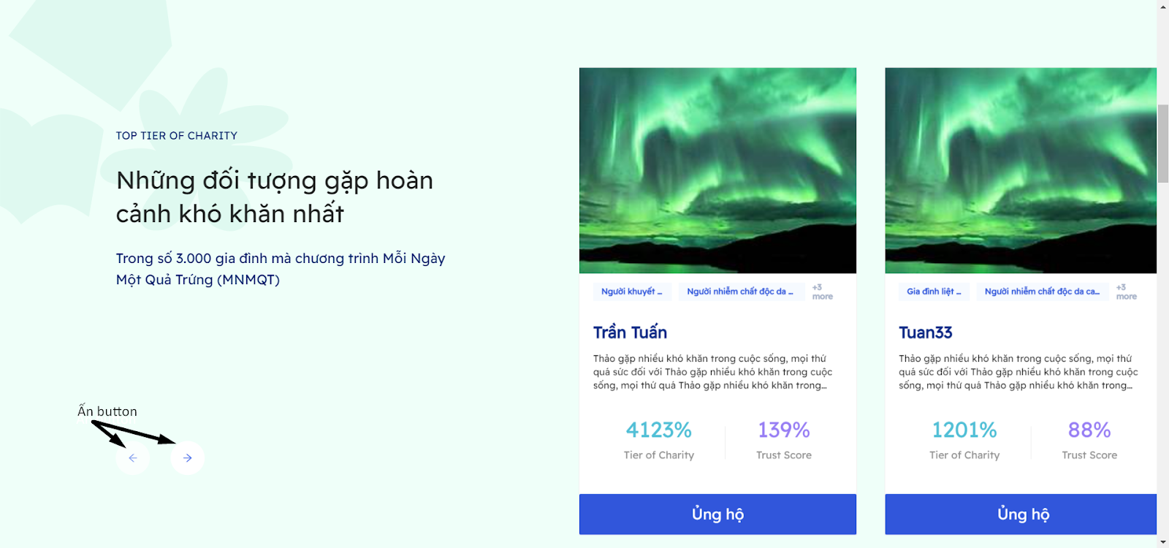

Step 1: Open a web browser

Step 2: Go to the <https://www.charityverse.info/>

Step 3: Scroll down below.

Step 4: Press the buttons to view other people. or click on the person's name to go to the person's profile there (Must login)

***1.4 View list categories of donation***

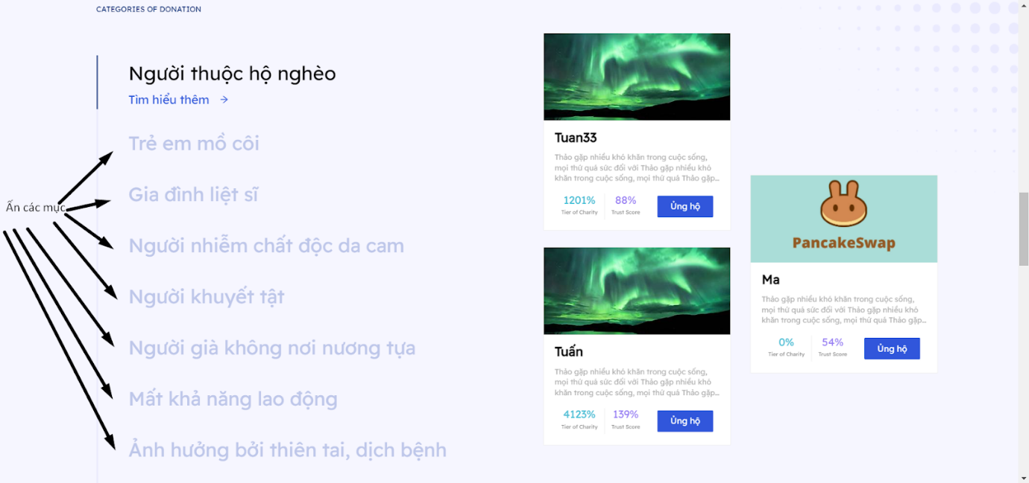

Step 1: Open a web browser

Step 2: Go to the <https://www.charityverse.info/>

Step 3: Scroll down below.

Step 4: Click items to see a list of equivalents. or click on the person's name to go to the fish page multiply that person (Must login)

***1.5 View list top philanthropist***

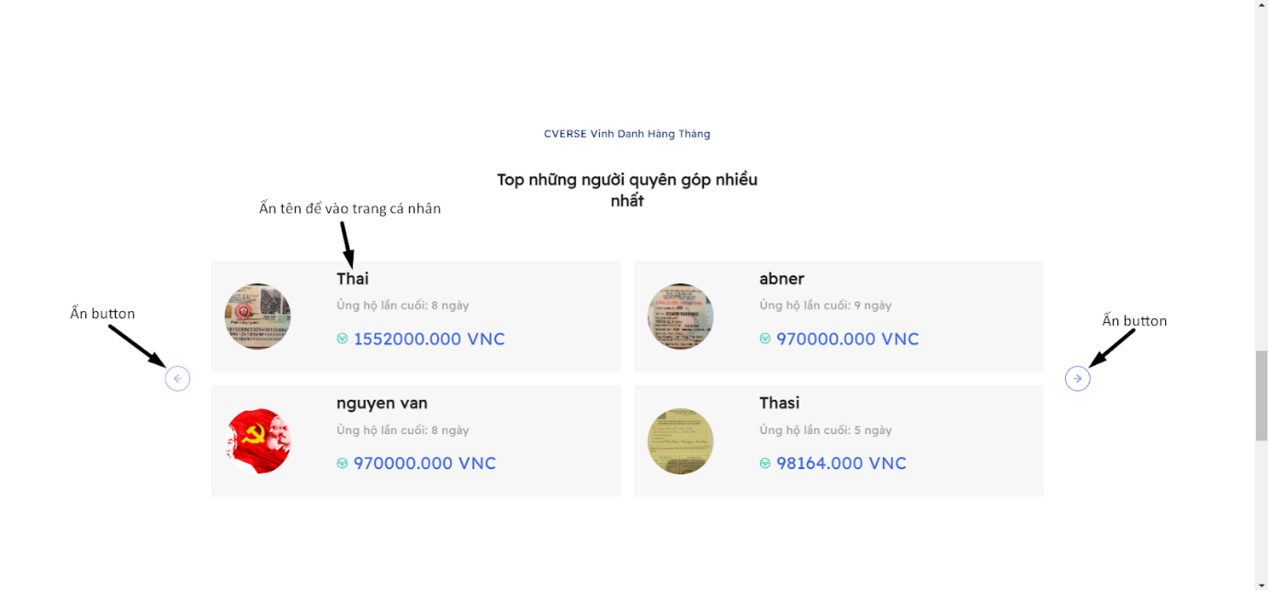

Step 1: Open a web browser

Step 2: Go to the <https://www.charityverse.info/>

Step 3: Scroll down below.

Step 4: Press the arrows to move the list or click on the person's name to go to the profile

  that person (Must login)

***1.6 Supporting***



Step 1: Open a web browser

Step 2: Go to the <https://www.charityverse.info/>

Step 3: Click the Support buttons to go to the user's profile page.

Step 4: The system asks you to log in, if you do not have an account, please see the instructions below.

**2 Login**

To login you must have a metamask wallet. If you don't have a metamask wallet, follow the instructions.  Follow the link below to have a metamask wallet on the device:

<https://kiwigroup.com.vn/huong-dan-su-dung-cai-dat-vi-metamask/>

After successfully creating the metamask wallet, please follow the steps below to log in system:



Step 1: Open a web browser

Step 2: Go to the <https://www.charityverse.info/>

Step 3: Click button to connect wallet

Step 4: Click button “Ký”



Step 5: Click button”Sign in”

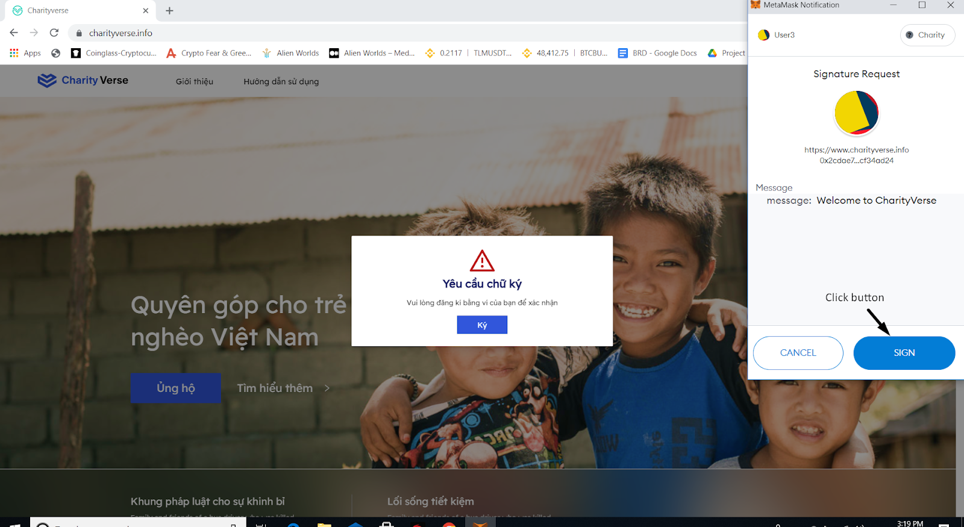

Step 6: Click button “Vào ứng dụng”



**3 Dashboard**

***3.1 Dashboard system***

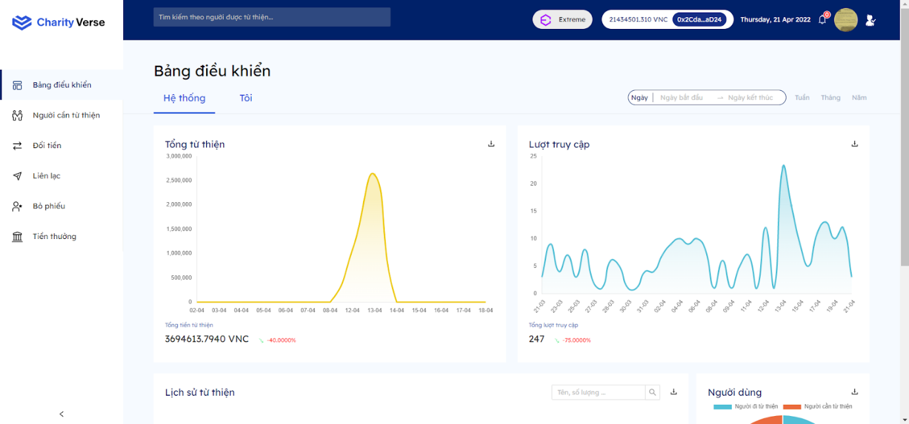

Step 1: Open a web browser

Step 2: Go to the <https://www.charityverse.info/>

Step 3: Login system with metamask wallet

3.1.1 View chart

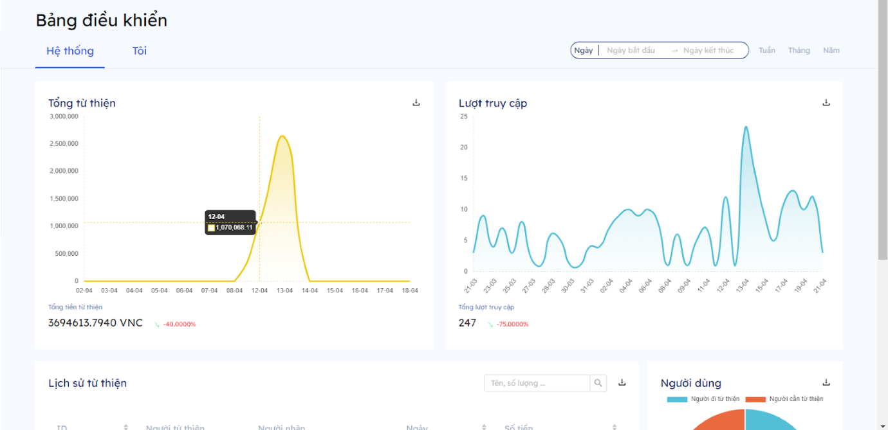

Move your mouse over the charts to see details.

3.1.2 Download chart

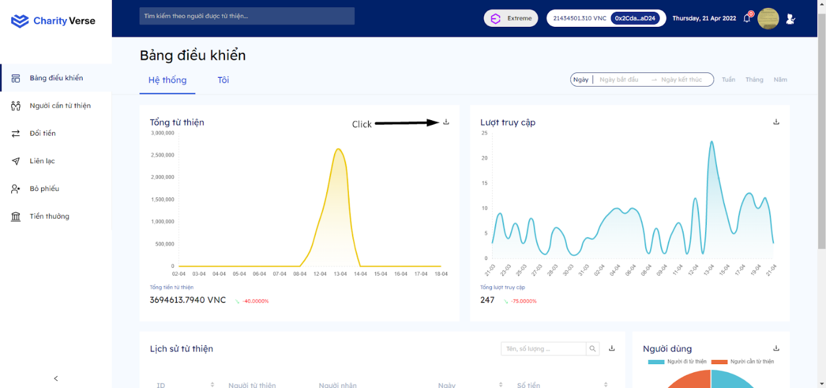

Click the download button to download the chart information to your computer

3.1.3 Search by date picker

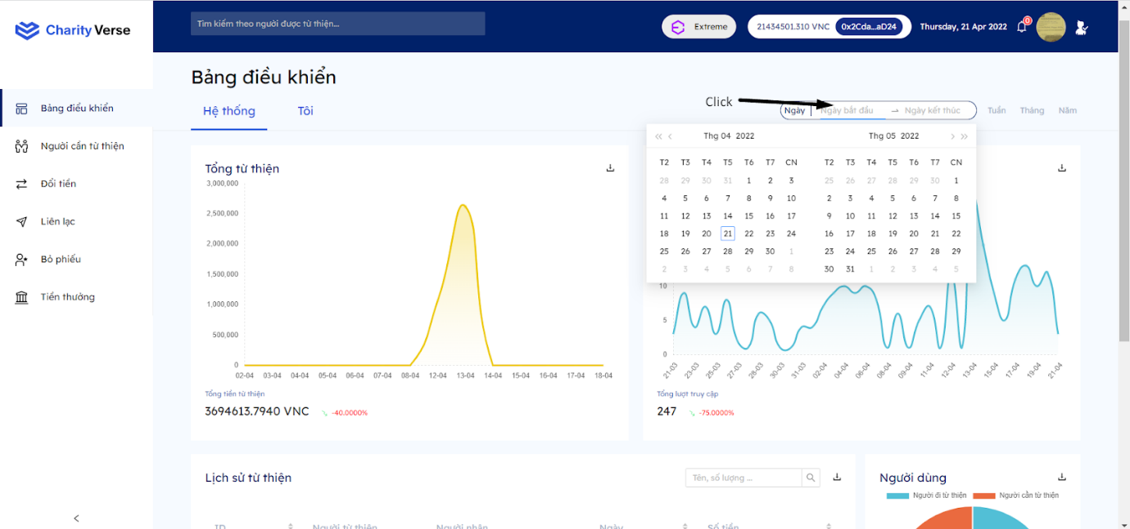

Step 1: Click vào datepicker

Step 2: Select the corresponding date

3.1.4 Sort

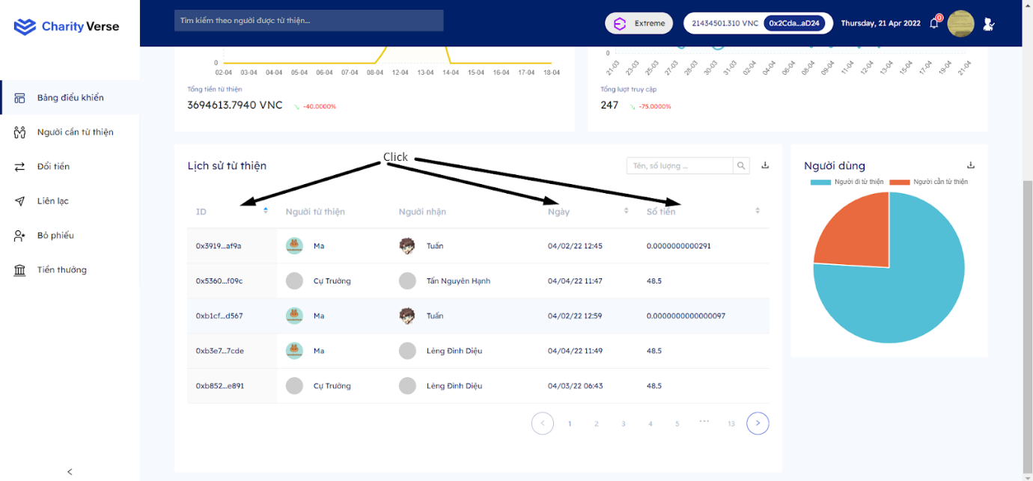

Step 1: Click on the columns you want to sort

Step 2: Going up is increasing, going down is decreasing

3.1.4 Search

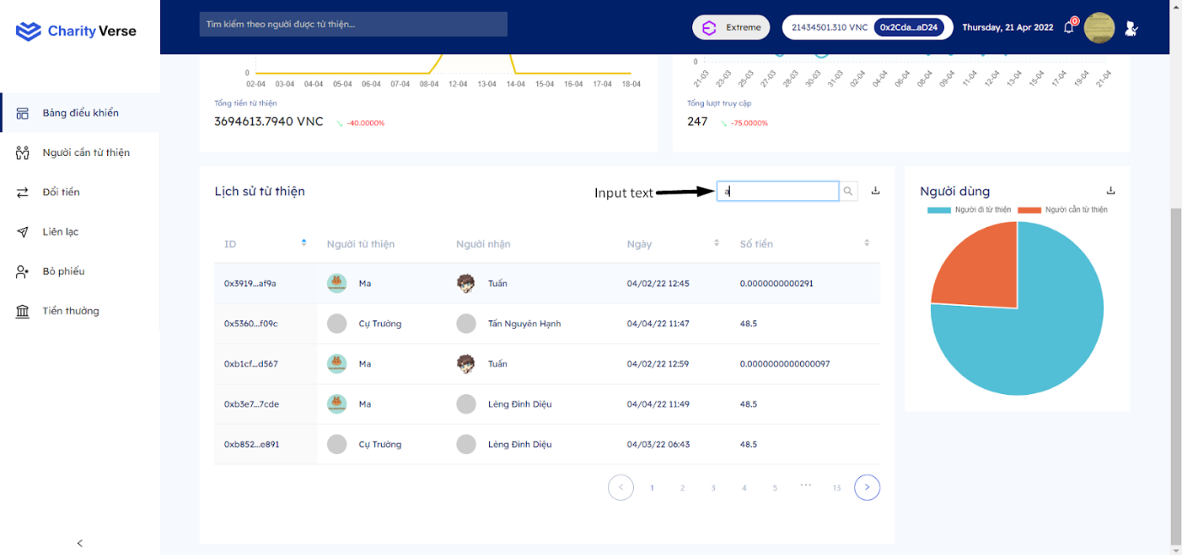

Step 1: Input text into the search box

Step 2: The system automatically changes the list.

***3.2 Dashboard user***

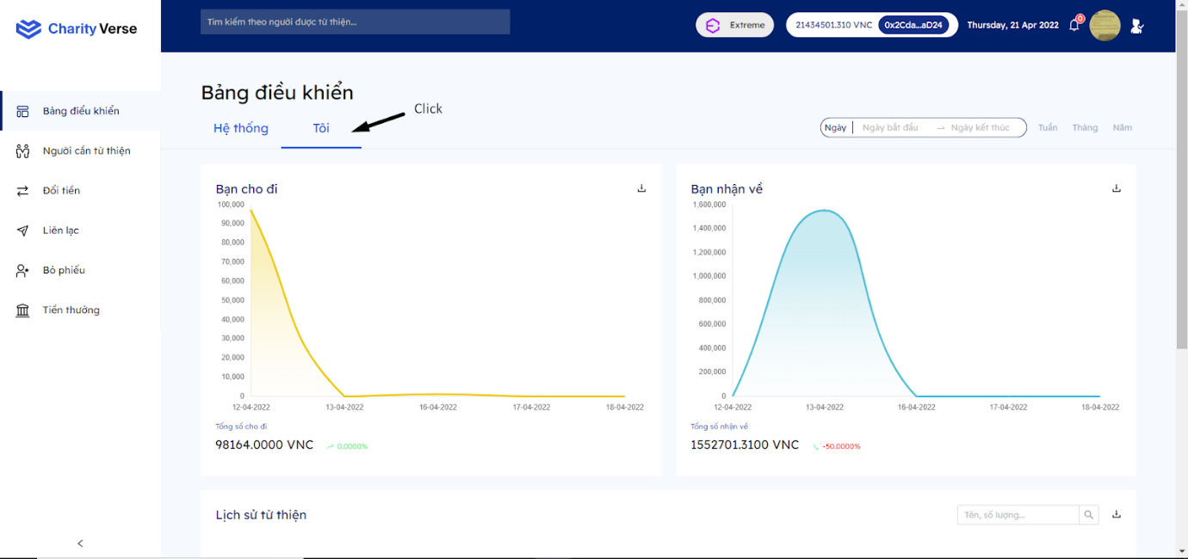

Step 1: Click tab “Tôi”

***3.3 Copy address***

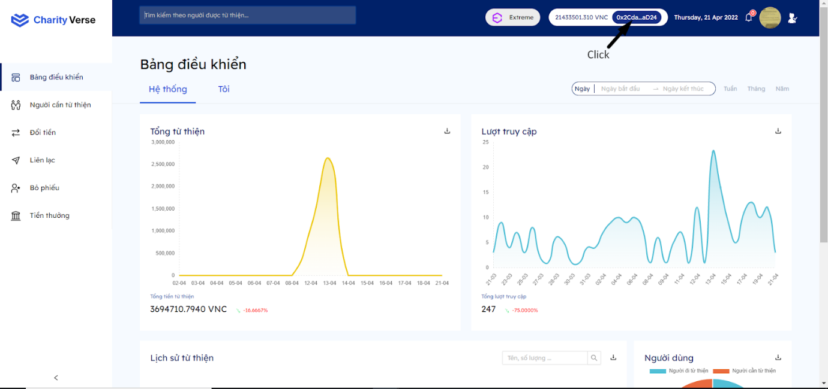

Step 1: Click vào address

**3.4 Donee**

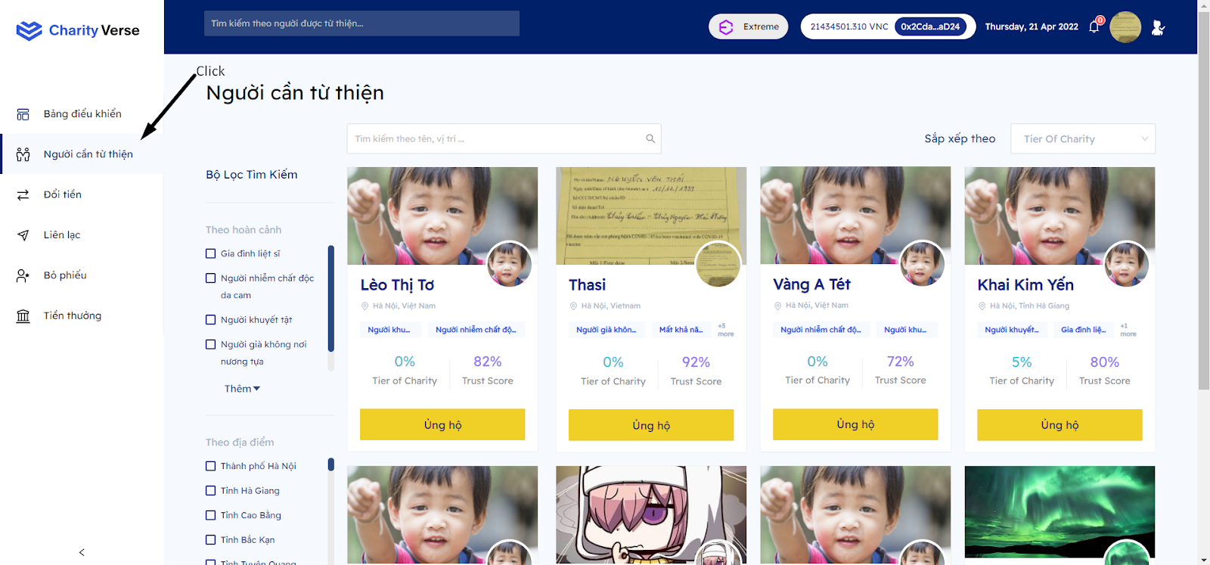

Step 1: Click page “Người cần từ thiện”

***4.1 Search***

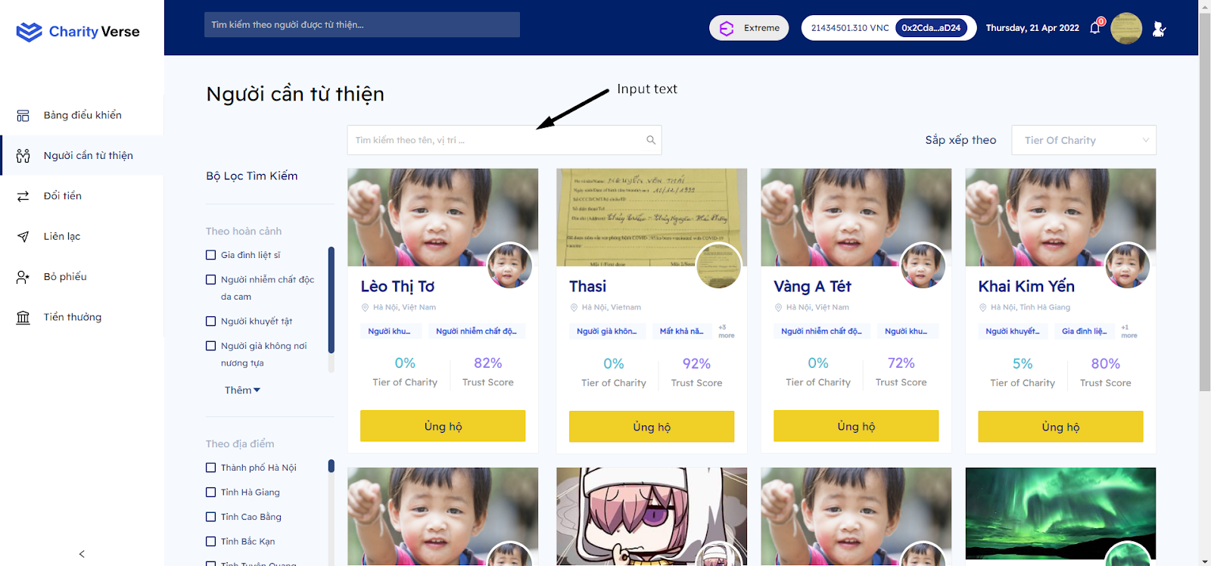

Step 1: Input text into the search box

Step 2: The system automatically changes the list according to the input

***4.2 Sort***

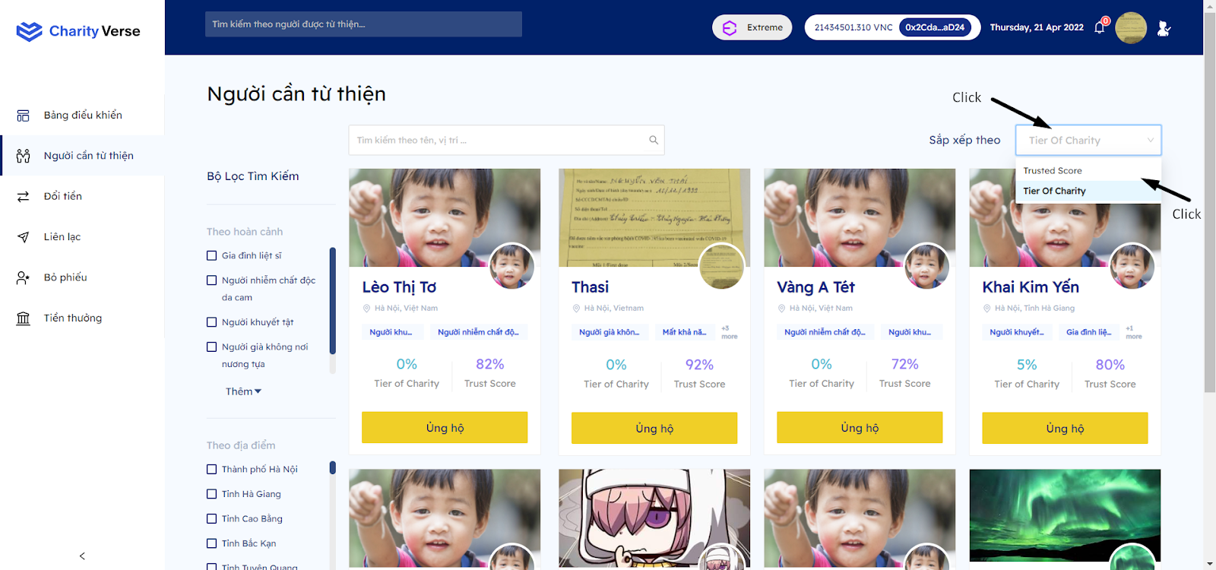

Step 1: Click on the sort box

Step 2: Choose the data you want to sort

Step 3: The system changes information gradually.

***4.4 Filter***

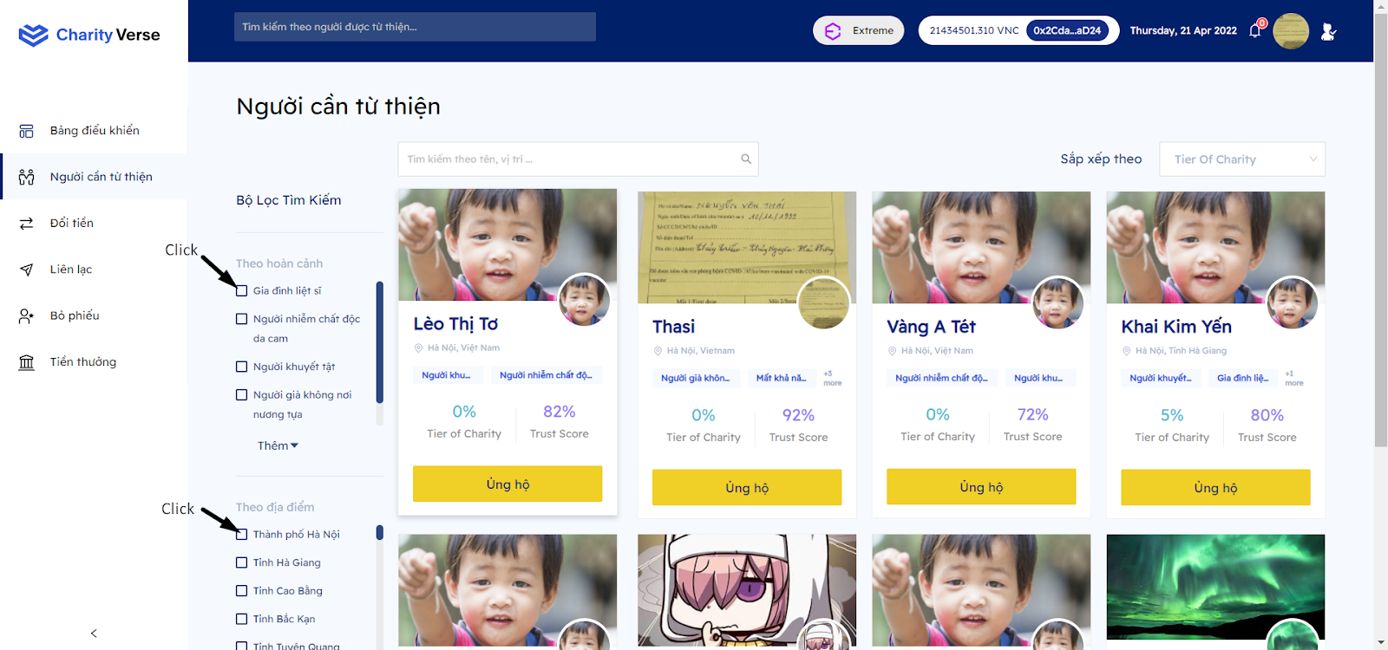

Step 1: Click on the checkboxes for the information you want to search

Step 2: The system displays a list according to the information you search.

***4.5 View another page***

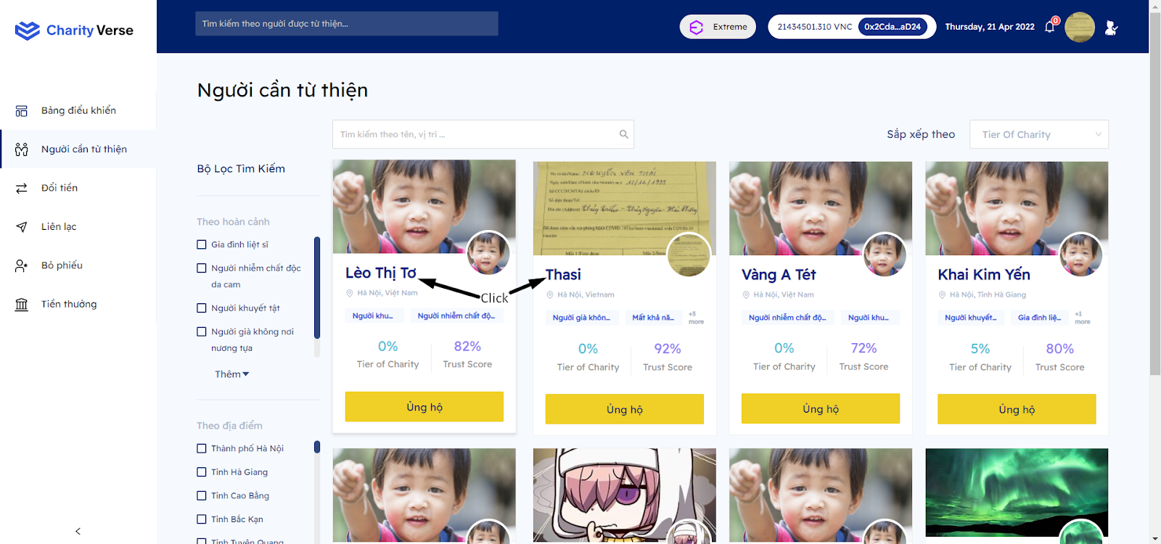

Step 1: Click on the username.

Step 2: The system takes you to the user's profile page.

***4.6 Donate***

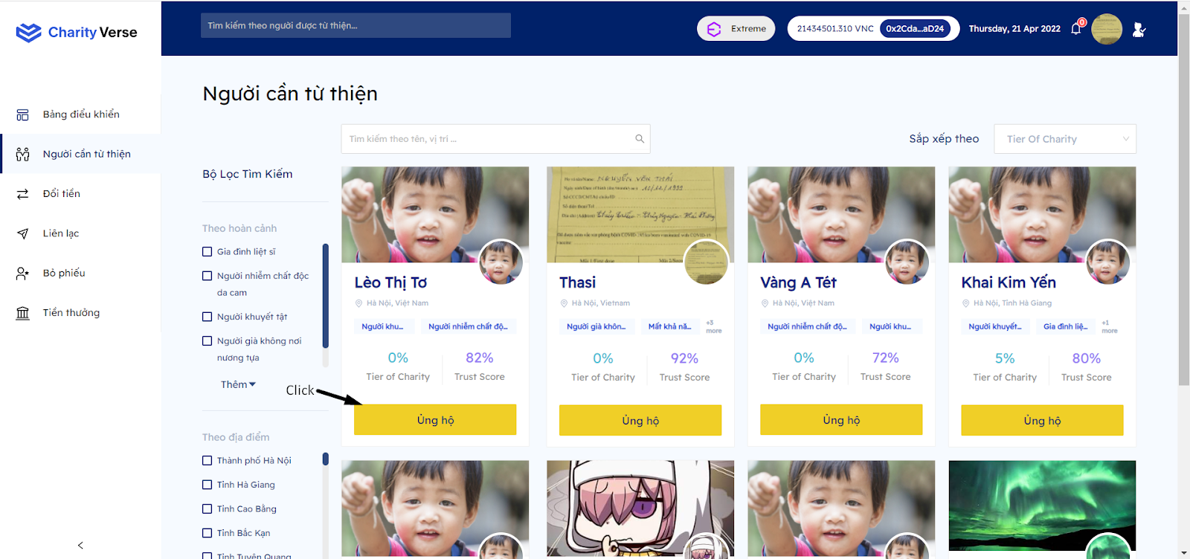

Step 1: Click button “Ủng hộ”

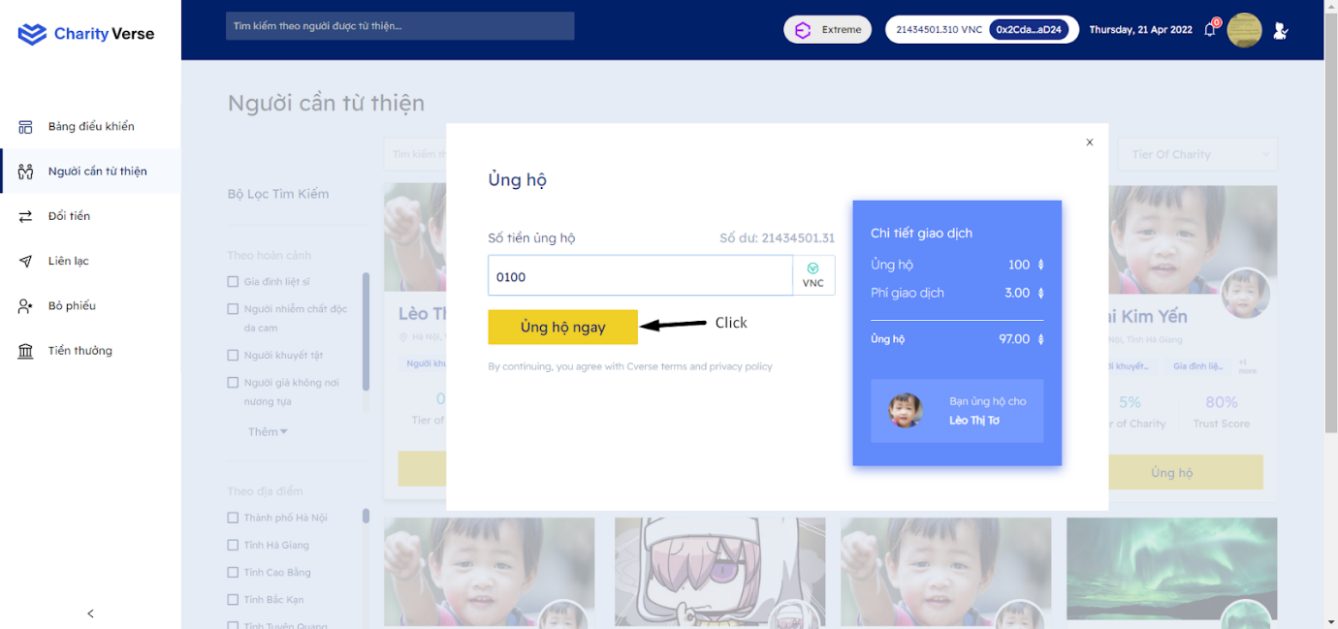

Step 2: Enter the number of coins you want to support

Step 3: Click “Ủng hộ ngay”

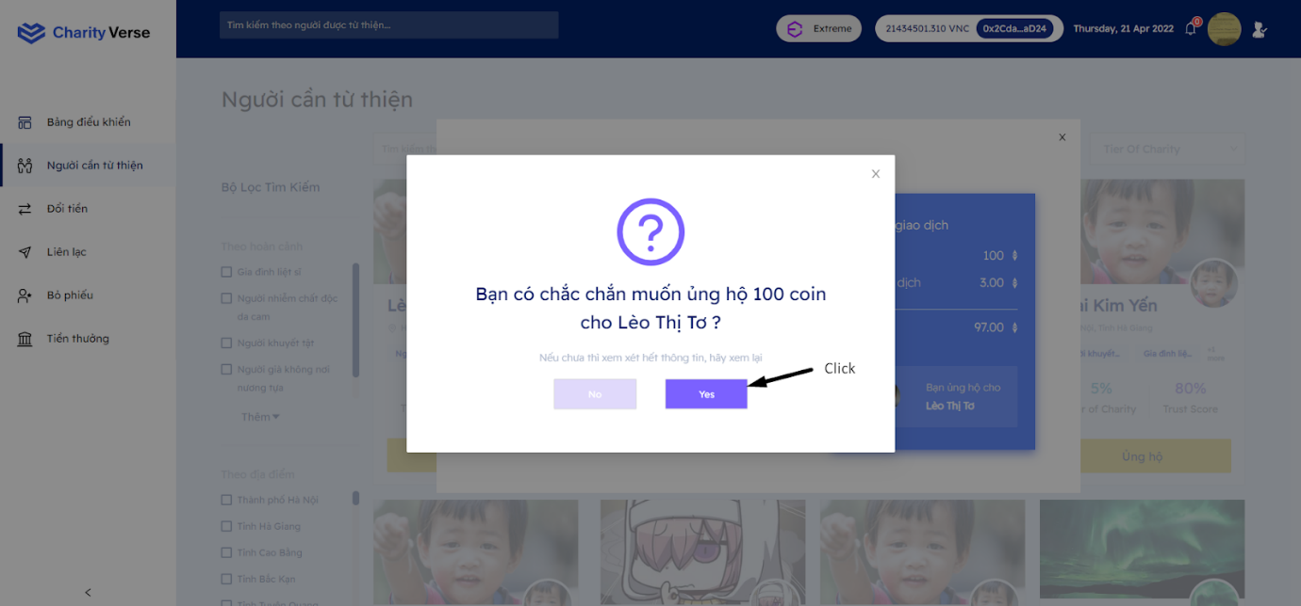

Step 4: Click “yes”

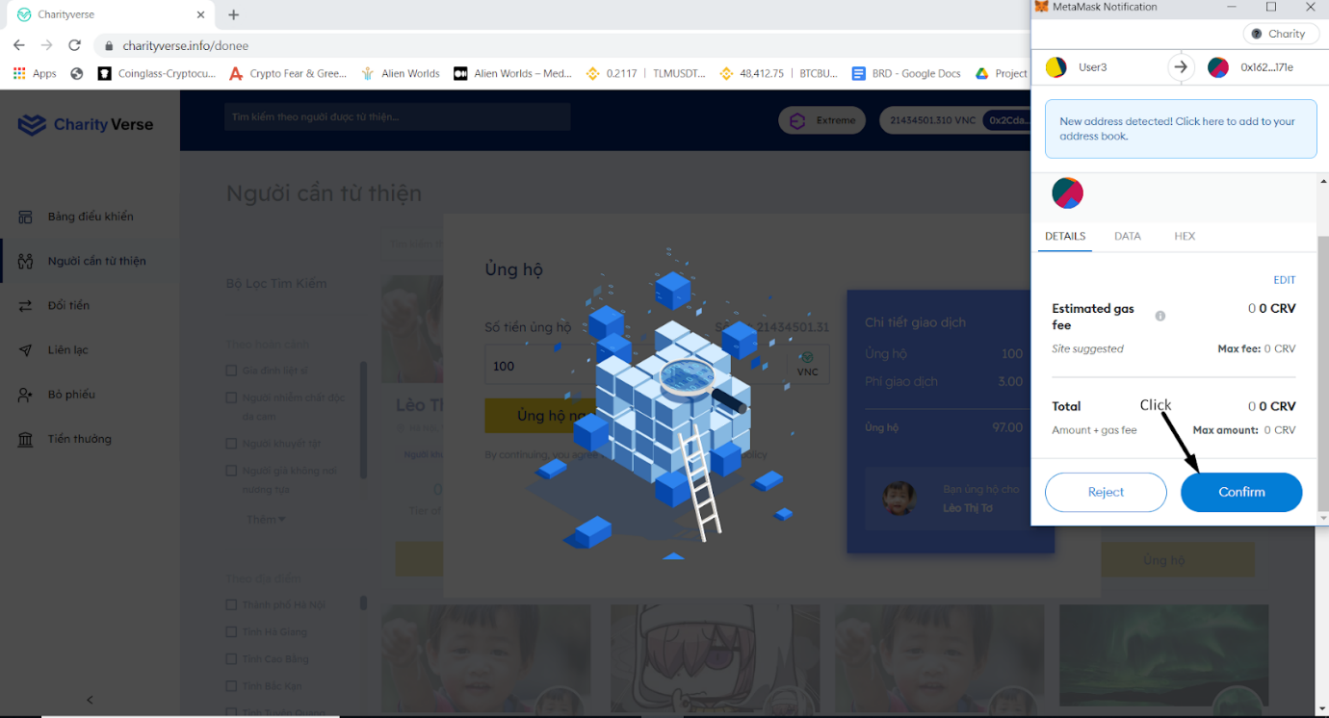

Step 5: Click “Confirm” trên metamask

**5 Exchange money**

***5.1 Buy***

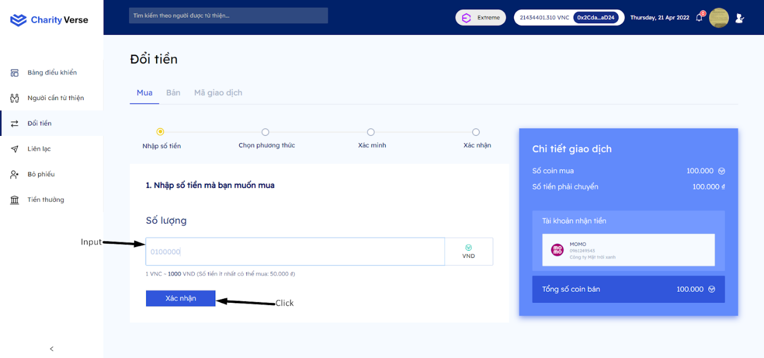

Step 1: Click page “Đổi tiền”

Step 2: Input the amount to buy (>50.000VND)

Step 3: Click “Xác nhận”

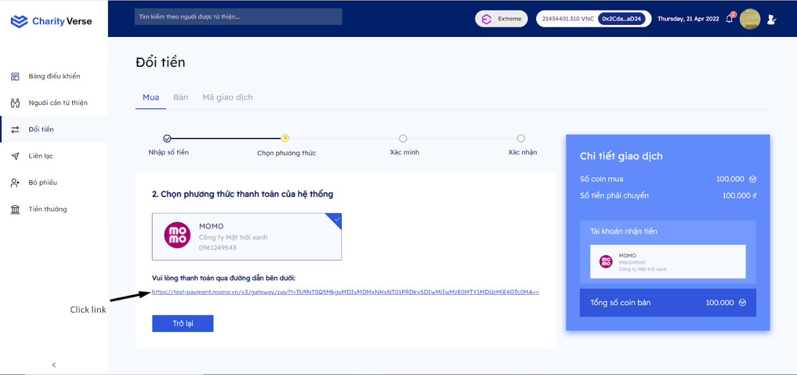

Step 4: Click the payment link

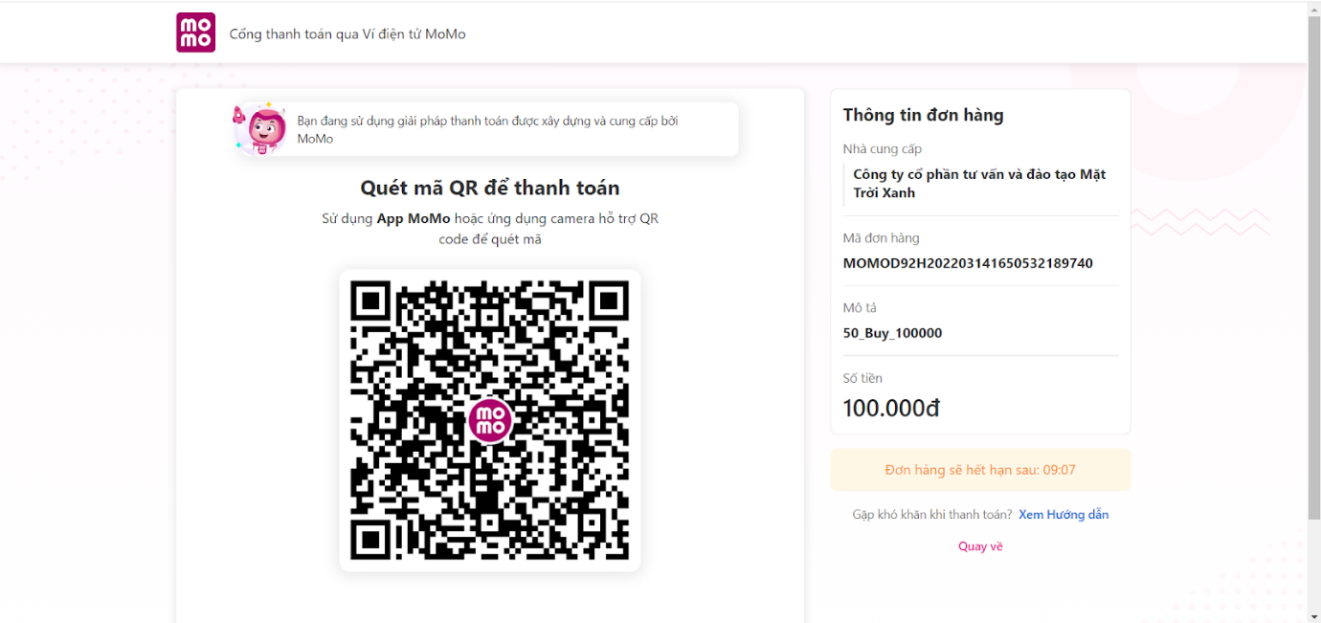

Step 5: Use your phone to scan the QR code to pay the bill

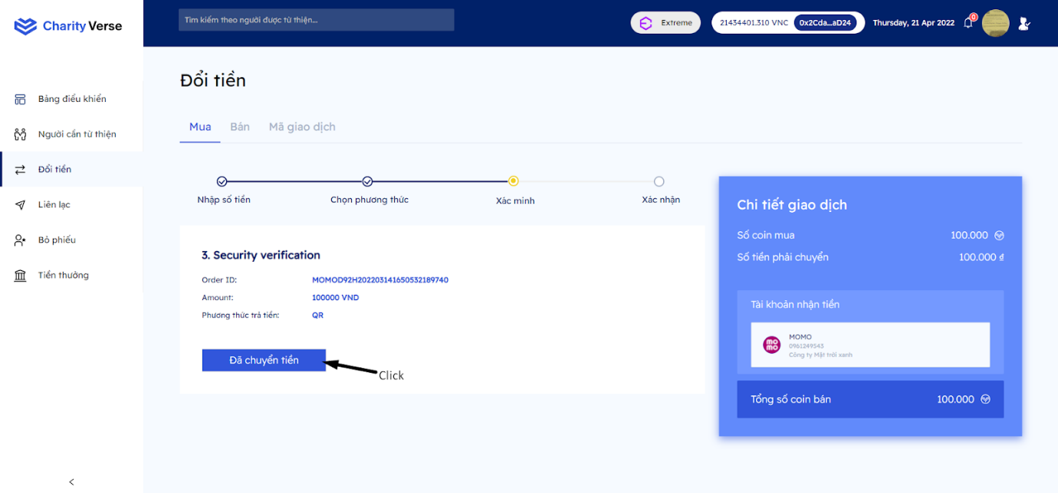

Step 6: Click “Đã chuyển tiền”

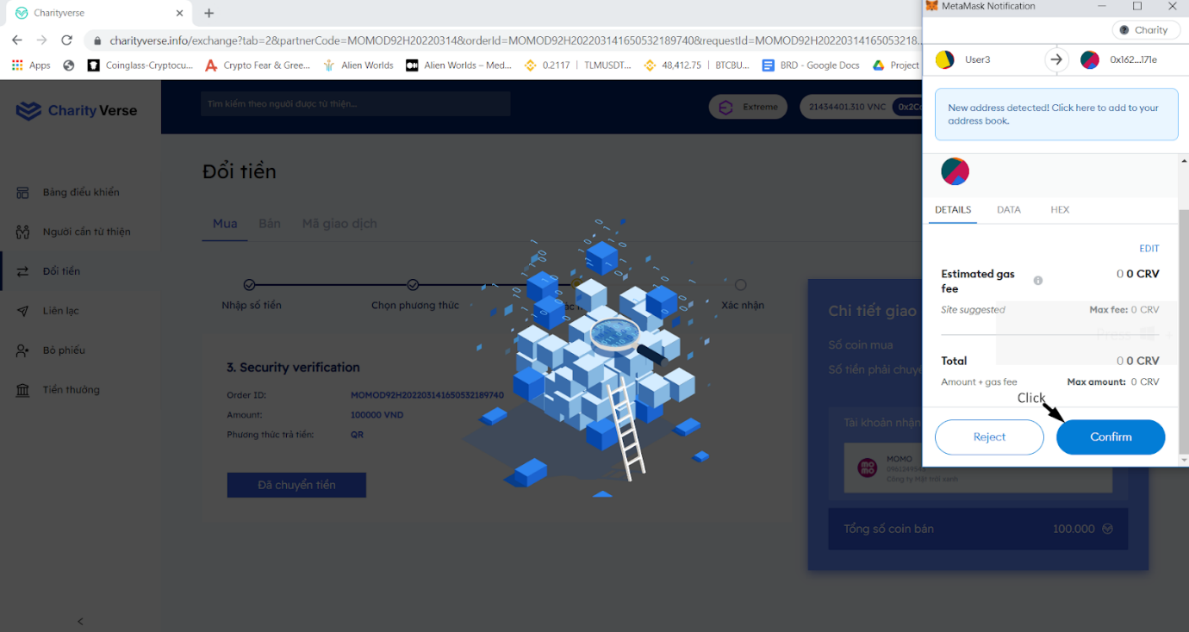

Step 7 : Click “Confirm” in metamask

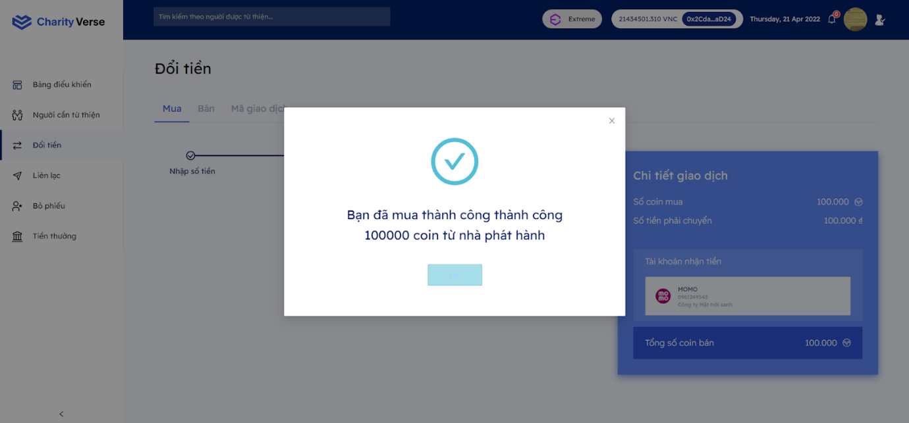

***5.2 Sell***

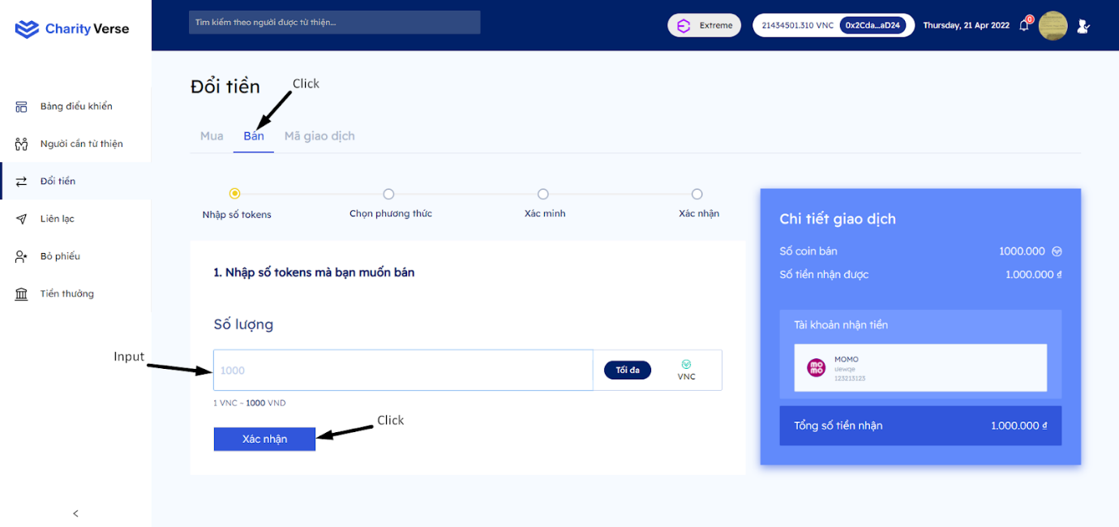

Step 1: Click tab “Bán”

Step 2: Enter the amount of coins to sell

Step 3: Click “Xác nhận”

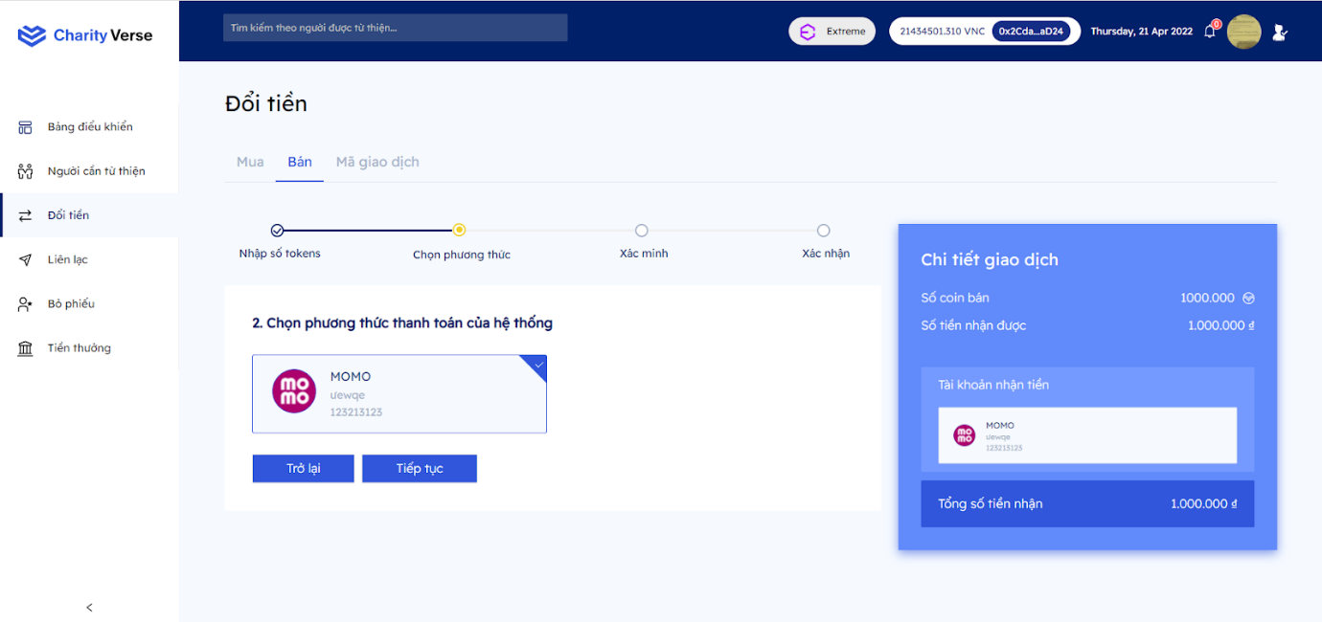

Step 4: Choose your payment method

Step 5: Click “Tiếp tục”

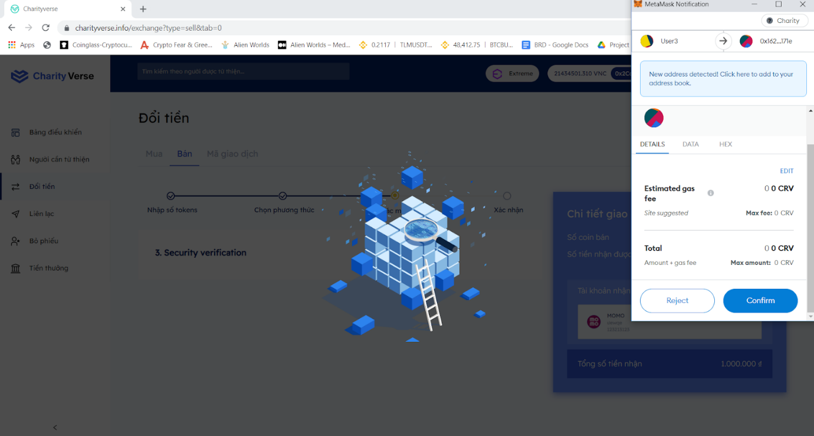

Step 6: Click “Confirm” in metamask

Step 7: The system will pay you within 24 working hours

***5.3 Transaction error***

In case your transaction fails, the system will report back, that you have not received the coin during the purchase process. You do the following steps:

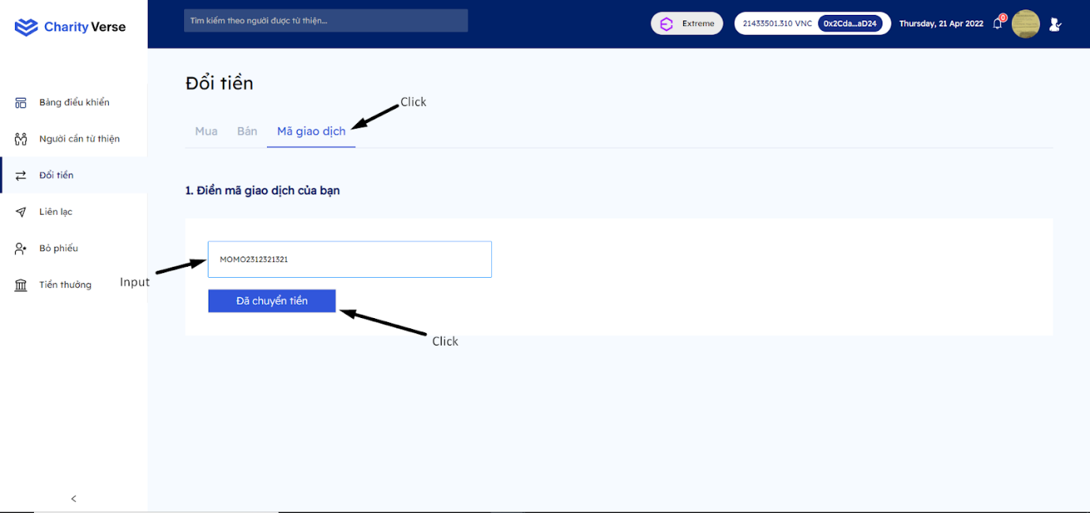

Step 1: Click tab “Mã giao dịch”

Step 2: Input momo transaction. If you don't know how to get the code, refer here

(<https://www.thegioididong.com/game-app/huong-dan-cach-xem-lich-su-giao-dich-vi-momo-tren-dien-thoai-1292842>)

Step 3: Click “đã chuyển tiền”.

**6 Voting**

***6.1 Search***

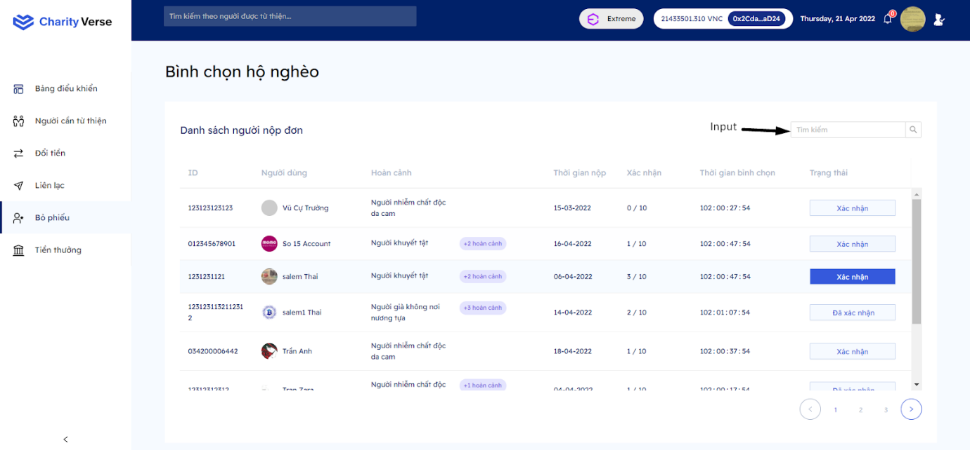

Step 1: Input text into the search box

Step 2: The system displays the list according to the search box

***6.2 Vote***

To be able to vote you need to log in with the account top philanthropist

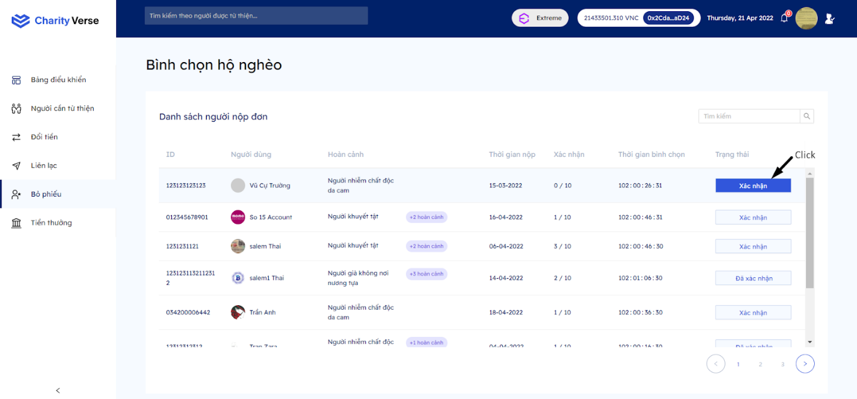

Step 1 : Click “Xác nhận”

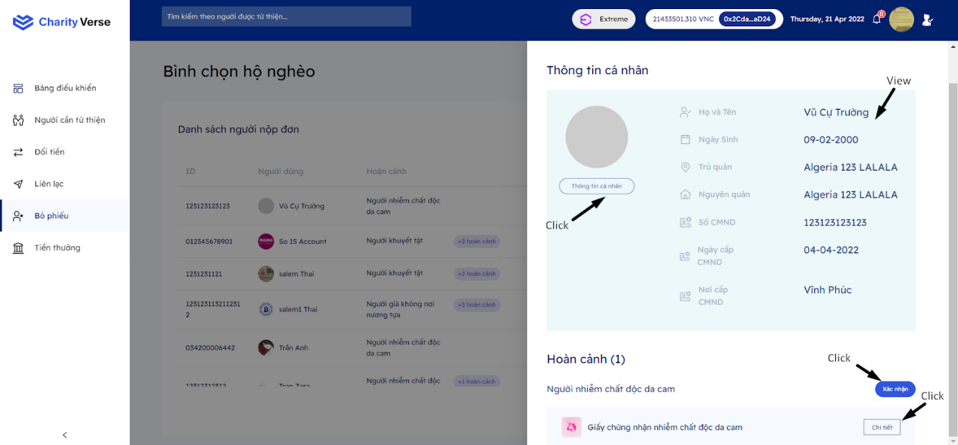

Step 2: View the personal information of the voter

Step 3: You can view detailed information by clicking ”Thông tin cá nhân” to enter the page

  user

Step 4: Click “Chi tiết” to view confirmation documents. Make sure the documents are fully signed and the red mark of the authorities

Step 5: Click “xác nhận”

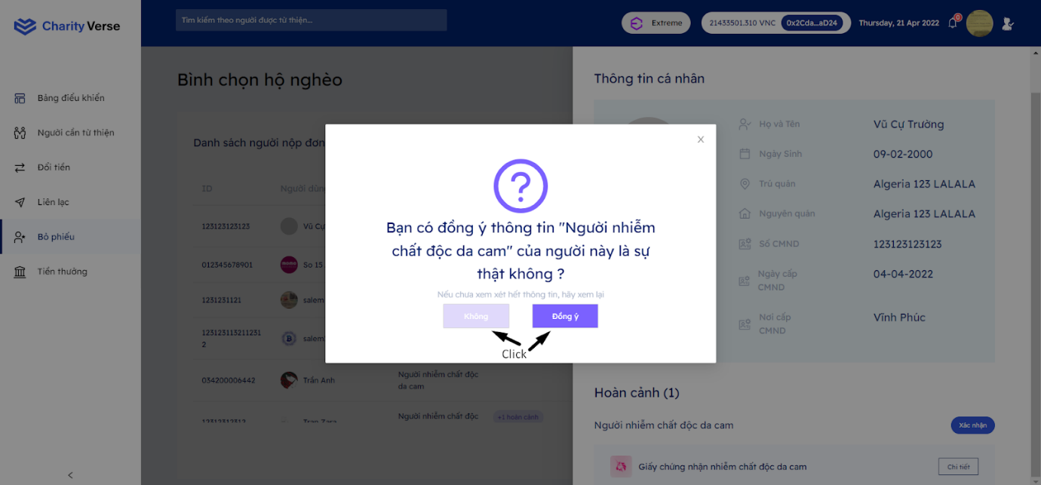

Step 6: Click “Đồng ý” if you think the documentation of the situation is valid. Otherwise, click “Không”

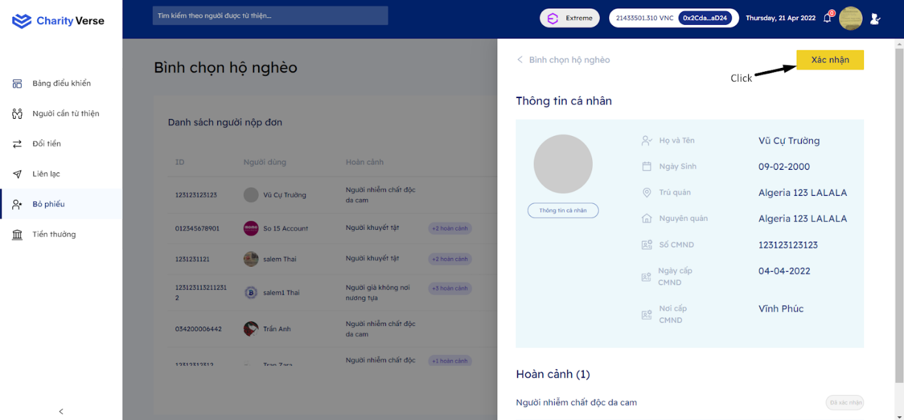

Step 7: After confirming all the circumstances, click “Xác nhận” to Vote for this person

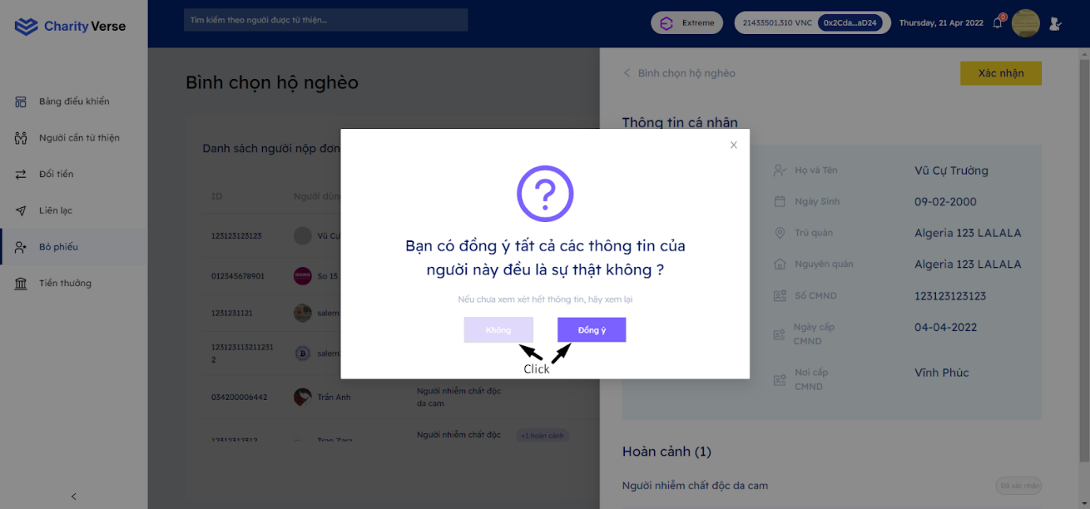

Step 8:  Click “Đồng ý” if you think this person's information is completely reliable. Otherwise click “Không”

**7 Get rewarded**

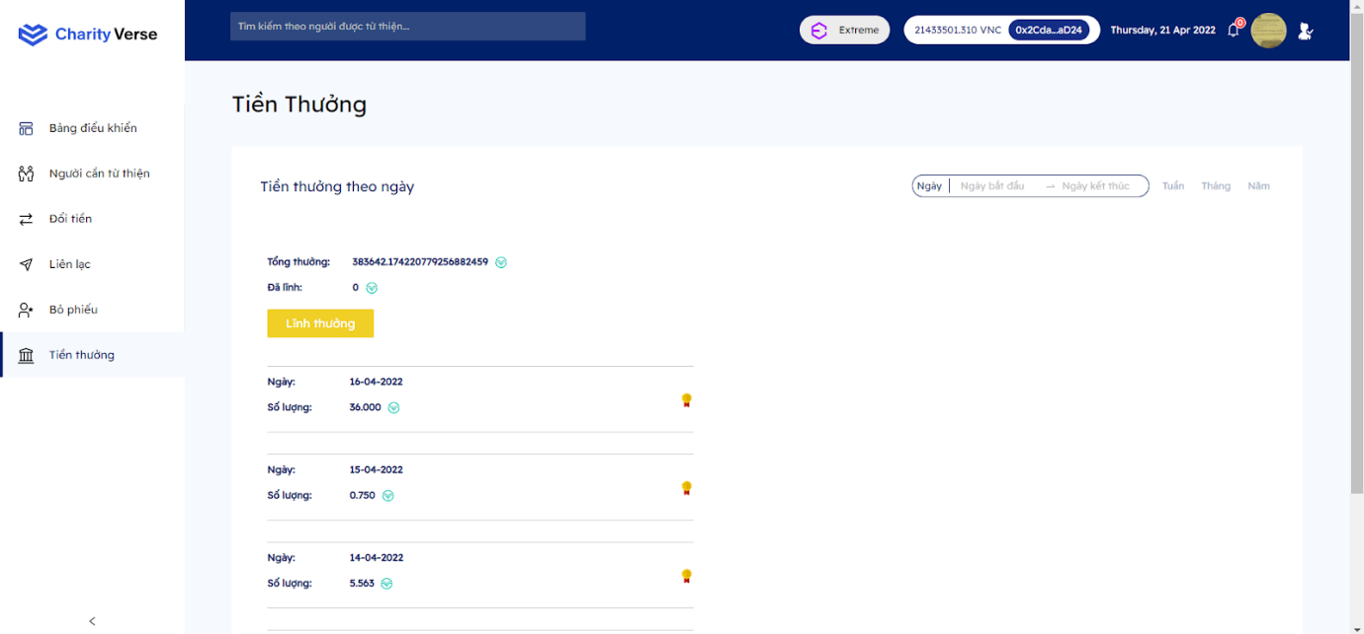

Step 1: Login with account top philanthropist

Step 2: Click tab “Tiền thưởng”

Step 3: Click get rewarded.

**8 Profile**

***8.1 Edit profile***

8.1.1 Update personal information

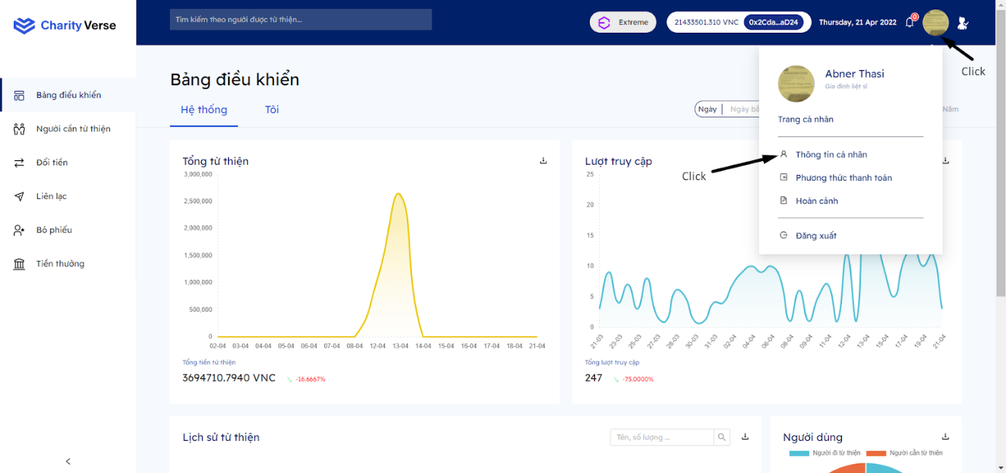

Step 1: Click the Avatar image in the right corner of the screen

Step 2: Click “Thông tin cá nhân”

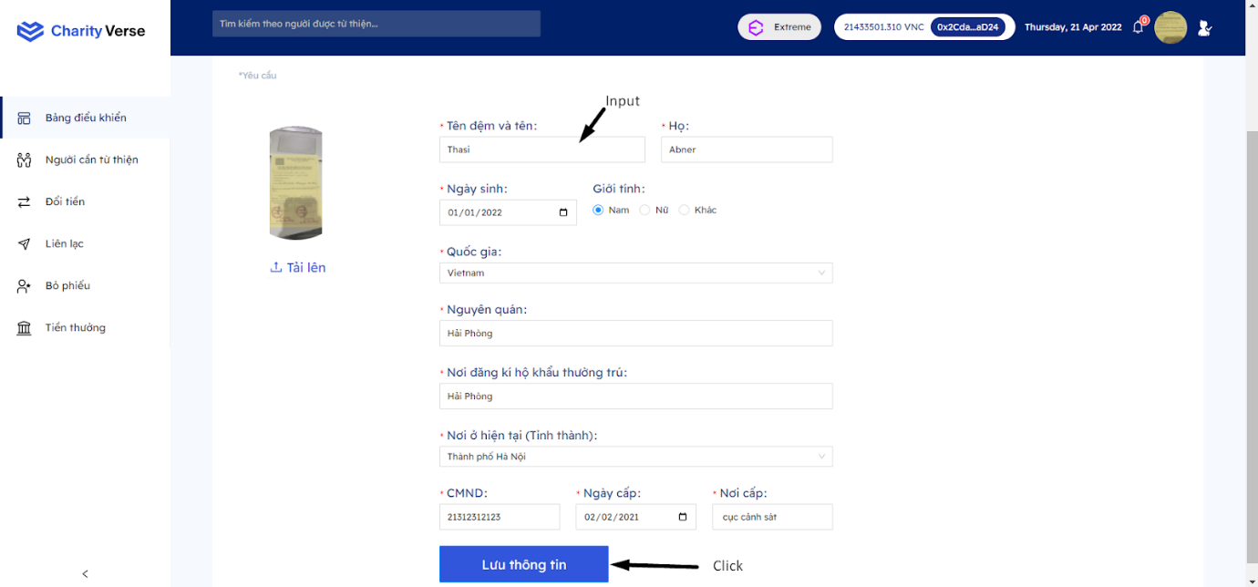

Step 3: Change personal information

Step 4: Click “lưu thông tin”

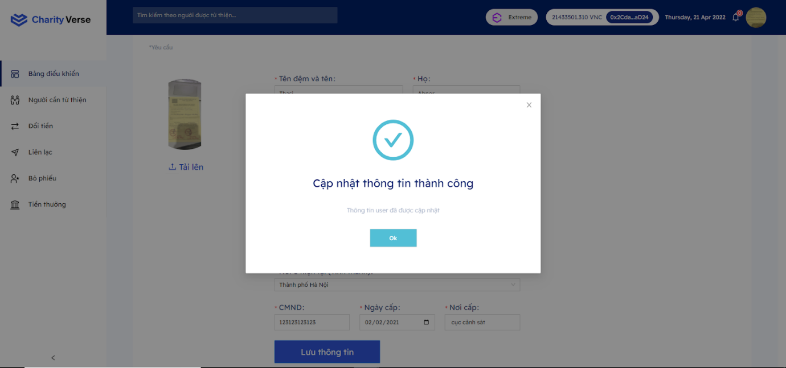

8.1.2 Update Payment method

**8.1.2.1 Edit**

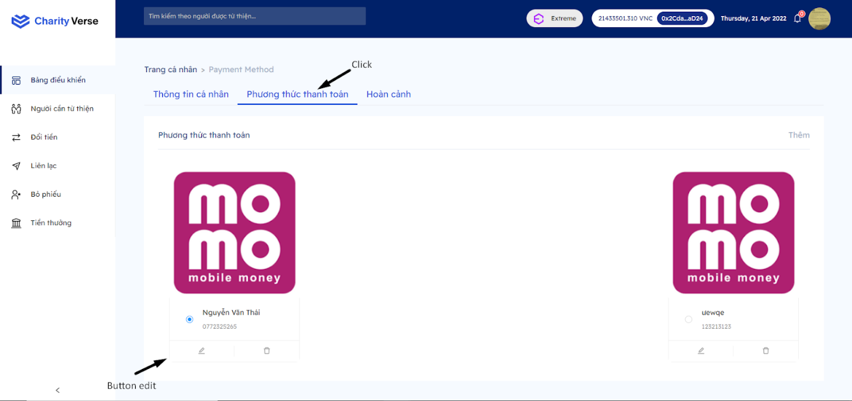

Step 1: Click tab payment methods

Step 2: Click button “Edit”

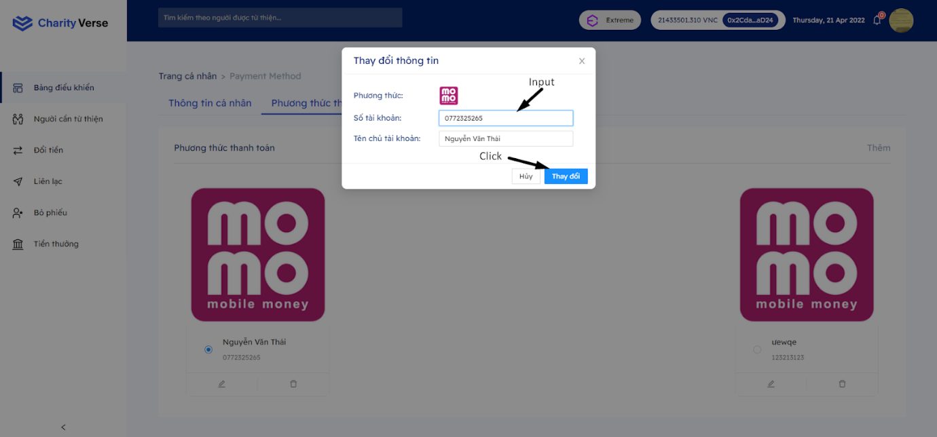

Step 3: Change information

Step 4: Click “Thay đổi”

**8.1.2.2 Delete**

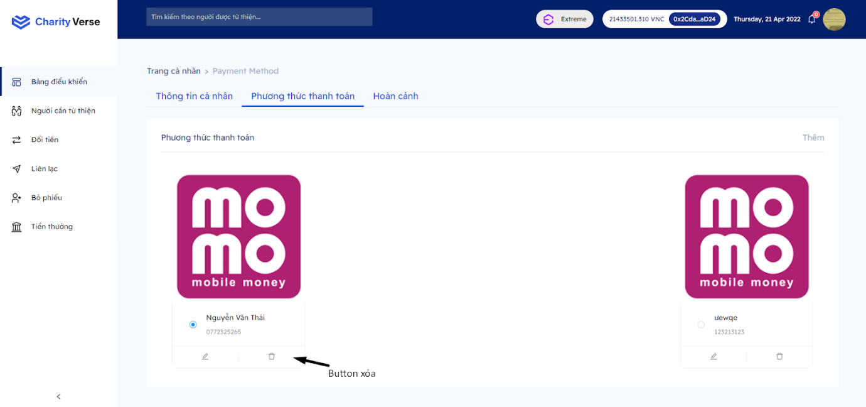

Step 1: Click button “Xóa”

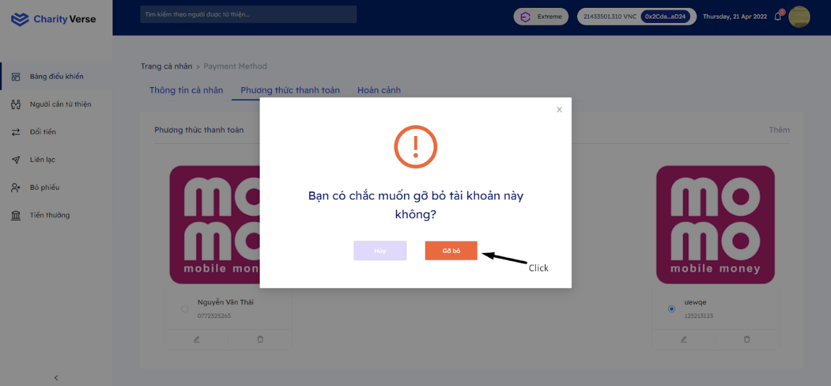

Step 2: Click “Gỡ bỏ”

**8.1.2.3 Add**

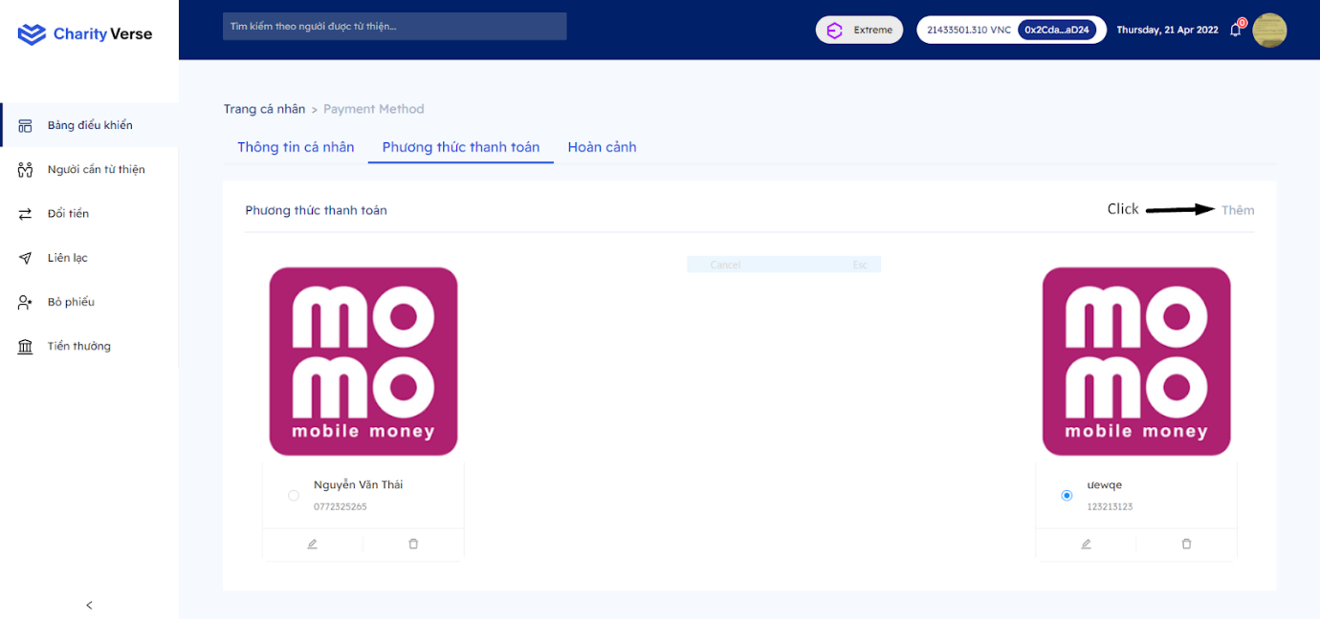

Step 1: Click “Thêm”

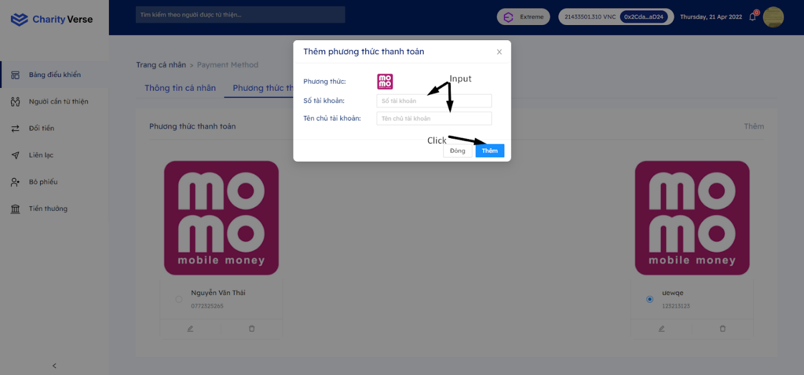

Step 2: Input information

Step 3: Click button “Thêm”

8.1.3 Update situation

You must log in with the user Donee, ie the person who has been confirmed by the system as a poor person to perform this function.

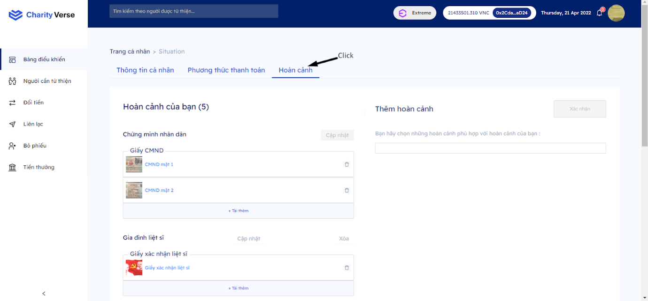

Step 1 : Click Tab “Hoàn cảnh”

**8.1.1 Add situation**

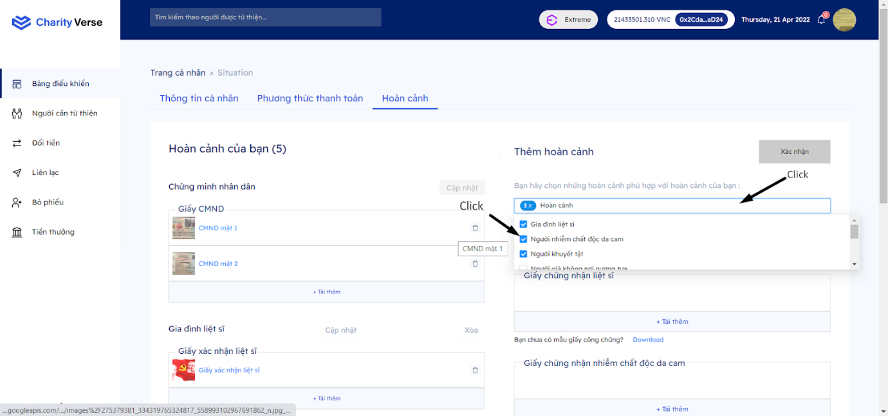

Step 1: Click on the box to select the situation

Step 2: Select the circumstances you want to add

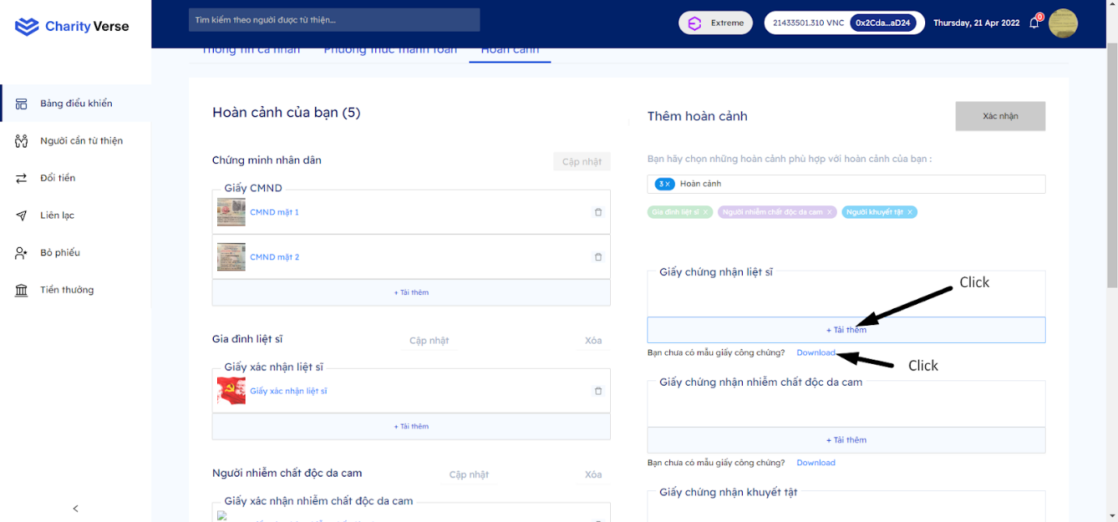

Step 3: Click download more if you already have a notarized certificate photo.

Step 3: Click download if you don't have the paper form yet

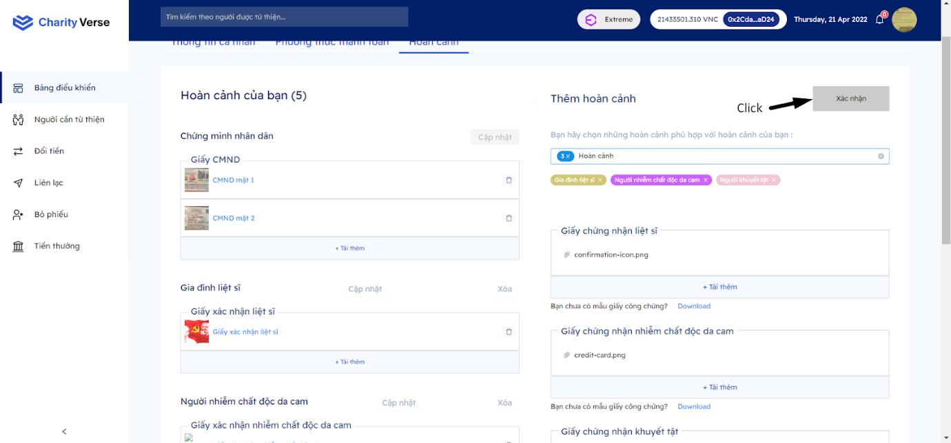

Step 4: Click “Xác nhận” after uploading all the pictures of each situation to the system

**8.1.2 Edit CMND**

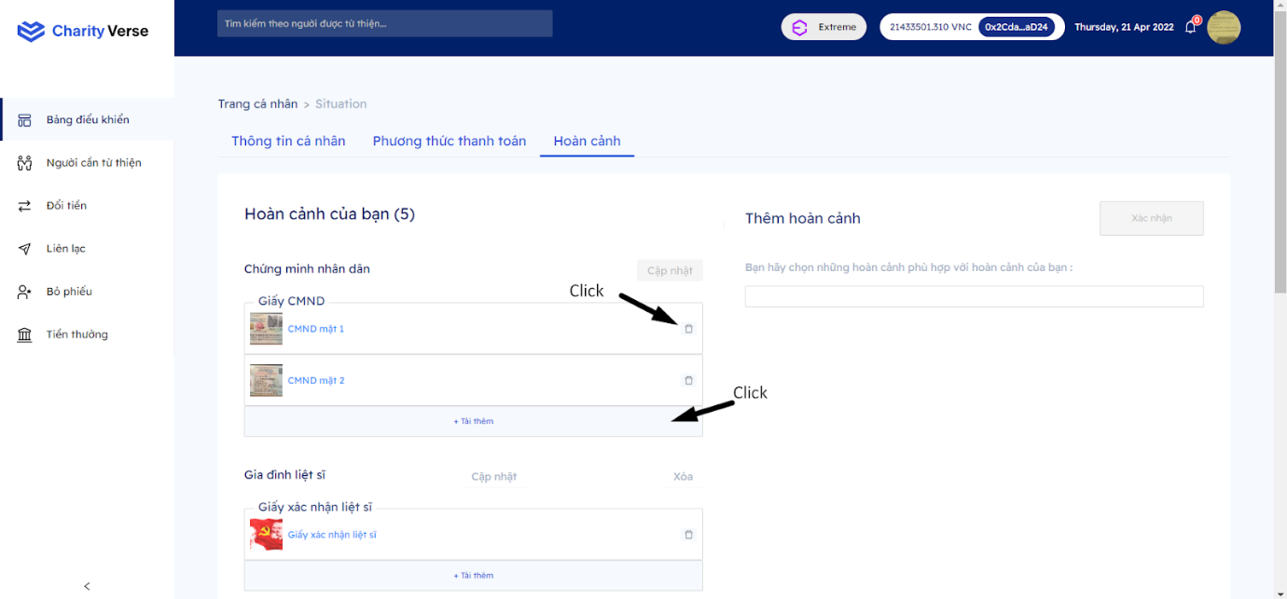

Step 1: Click button “Xóa” To delete the photo of ID card needs to be updated

Step 2: Click  “tải thêm” to upload photo of ID card into the system

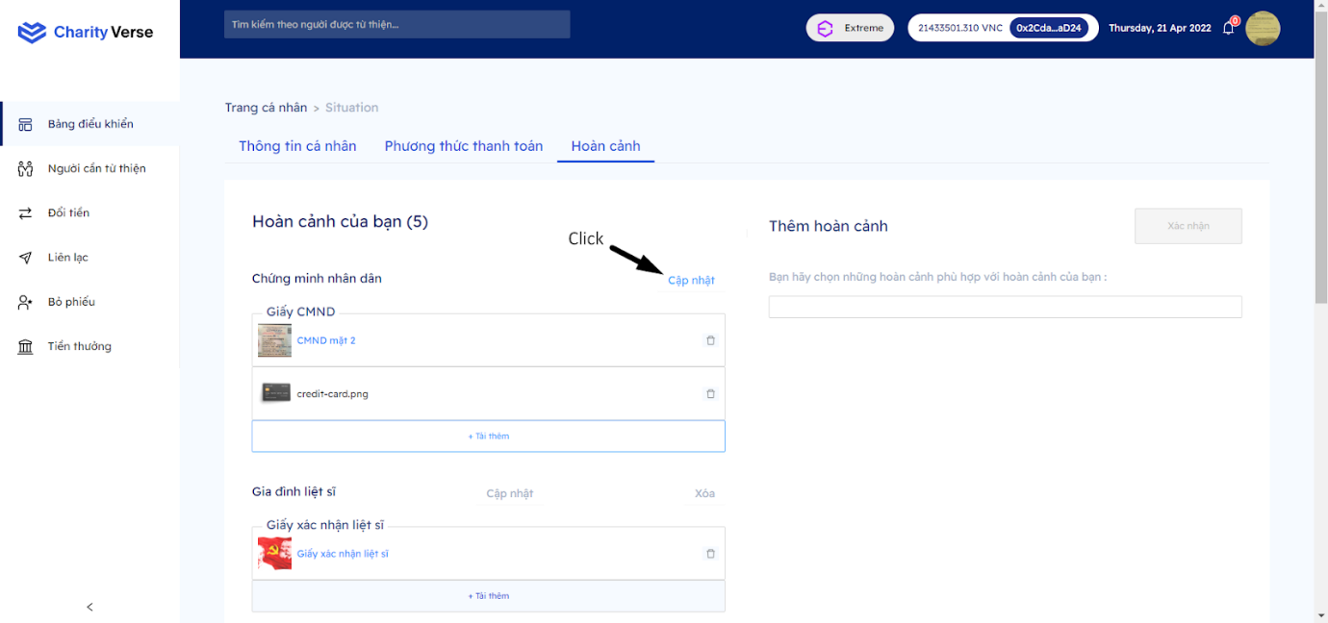

Step 3: Click “Cập nhật”

**8.1.3 Delete situation**

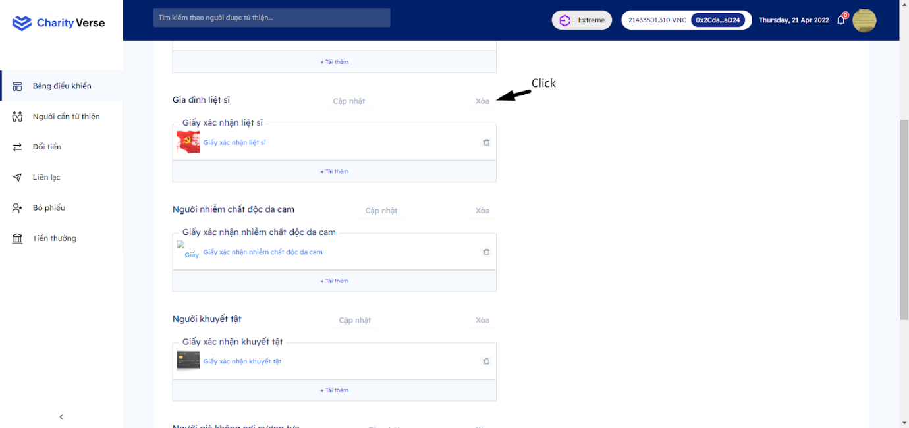

Step 1: Click button “xóa”

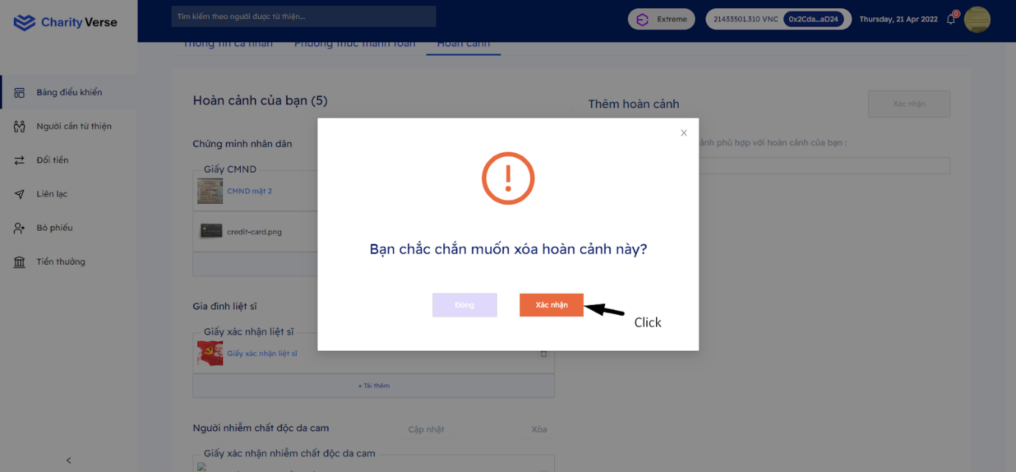

Step 2: Click “Xác nhận”

**8.1.4 Edit situation**

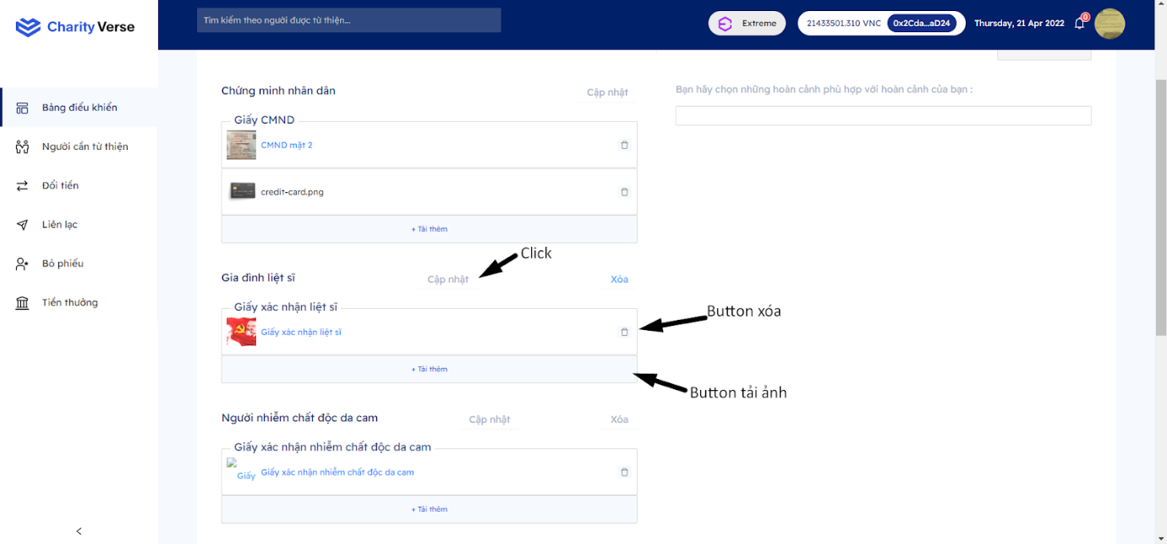

Step 1: Delete or upload more photos

Step 2: Click “cập nhật”

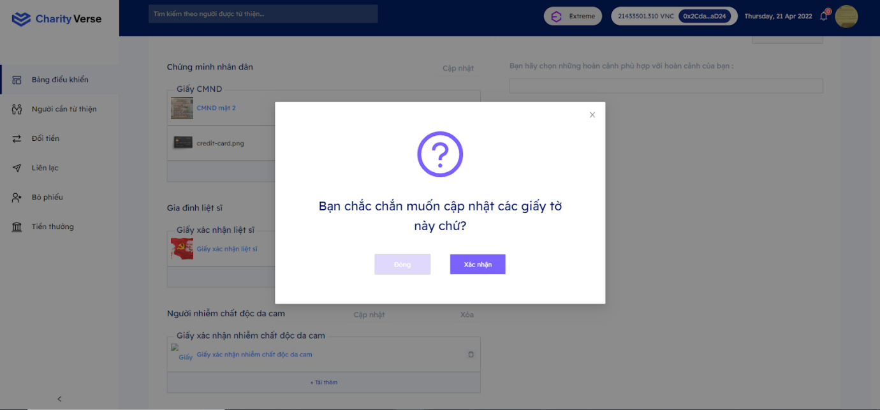

Step 3: Click “xác nhận”

***8.2. Personal Page***

8.2.1 My page

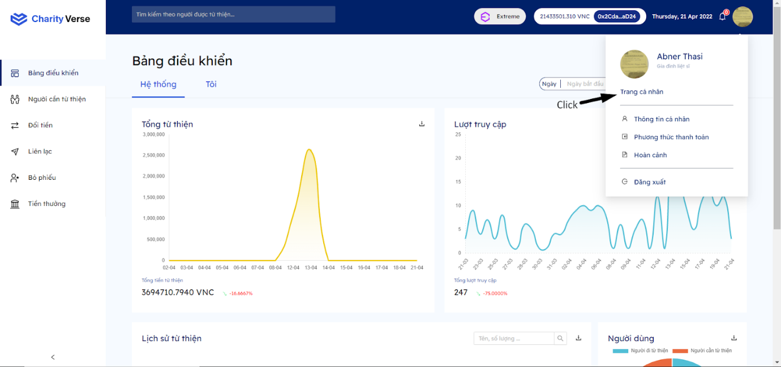

Step 1: Click personal page

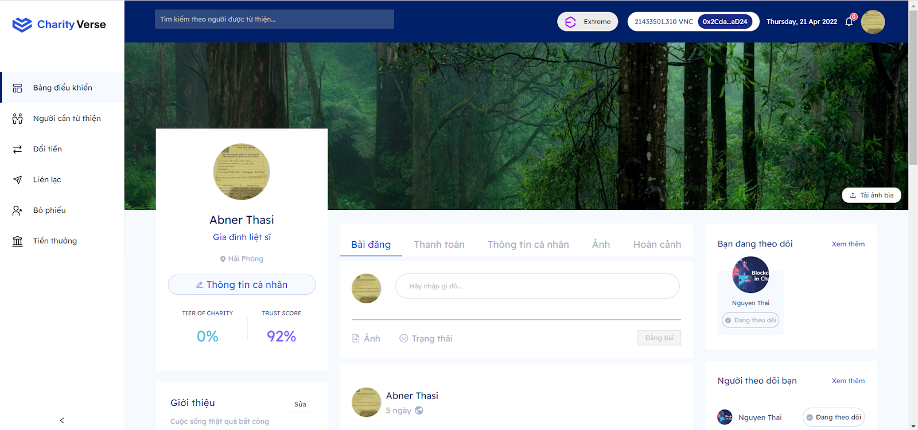

**8.2.1.1 Post**

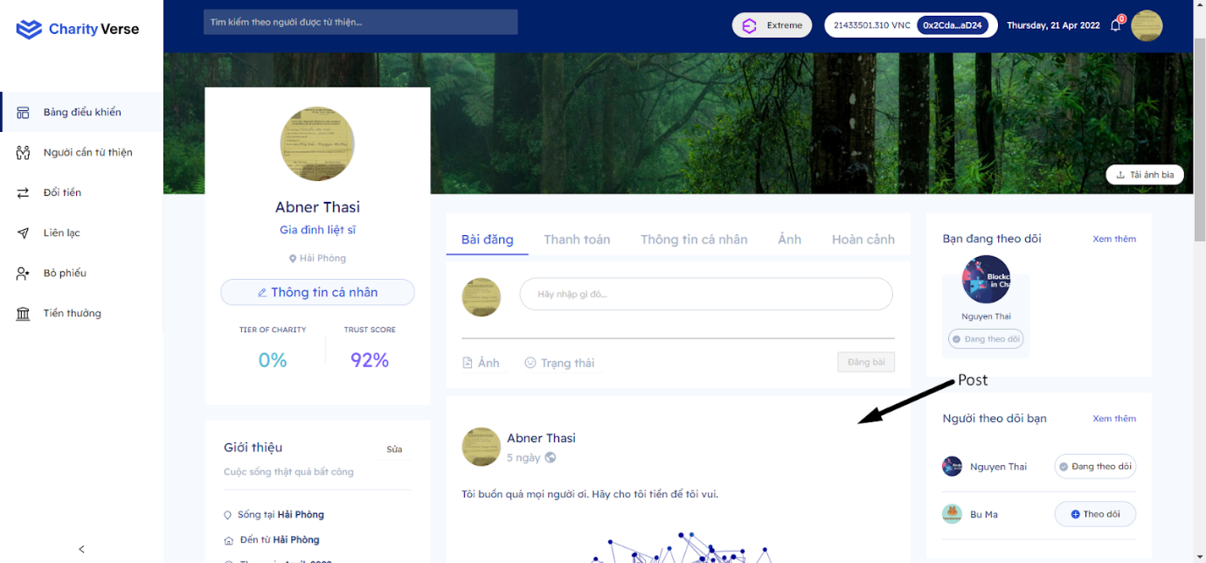

Step 1: Scroll to see the list of posts

8.2.1.1.1 Up post

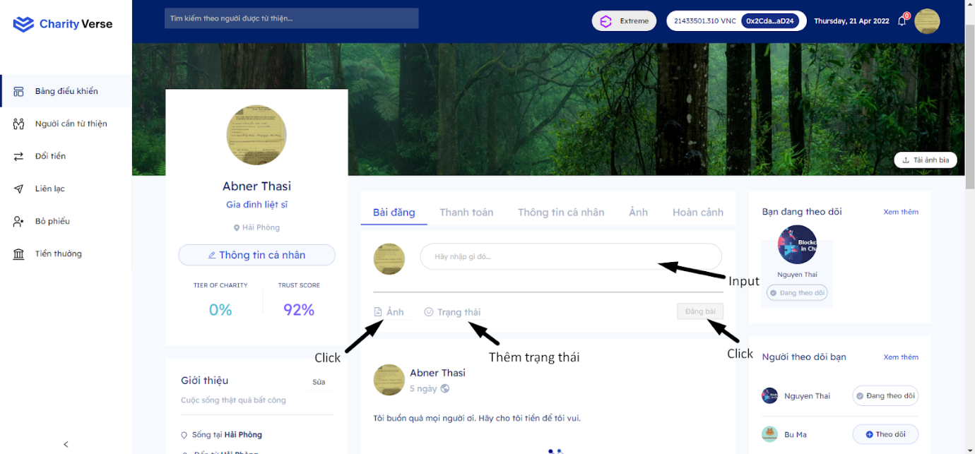

Step 1: Input text into the text box

Step 2: Can add a photo or status

Step 3: Click “đăng bài”

8.2.1.1.2 Like post

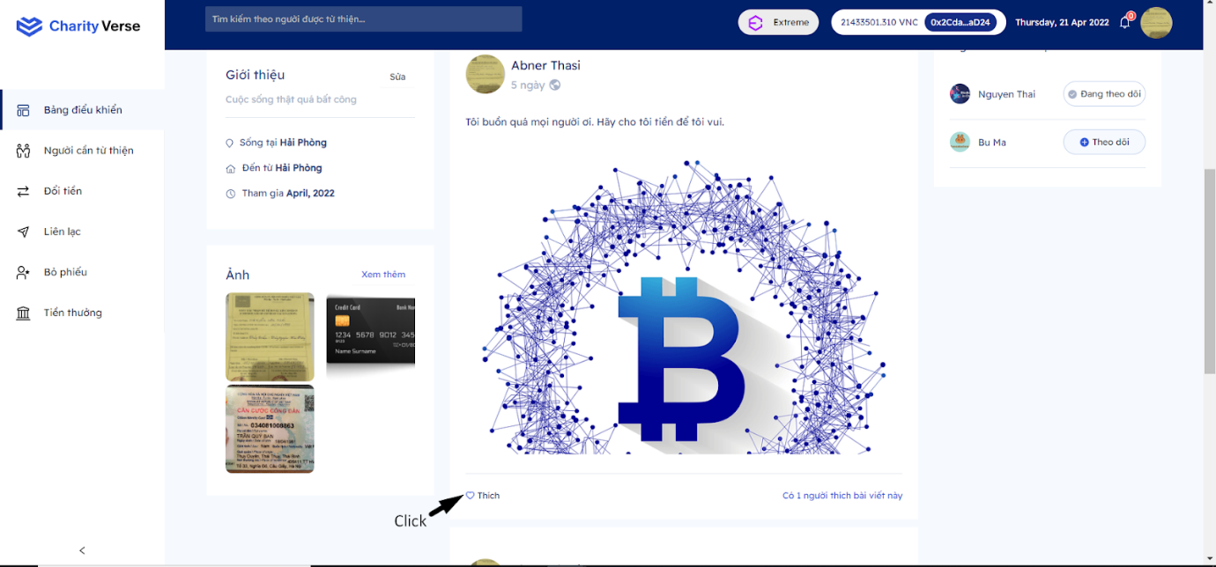

Step 1: Click button “trái tim”.

8.2.1.2 Update introduction

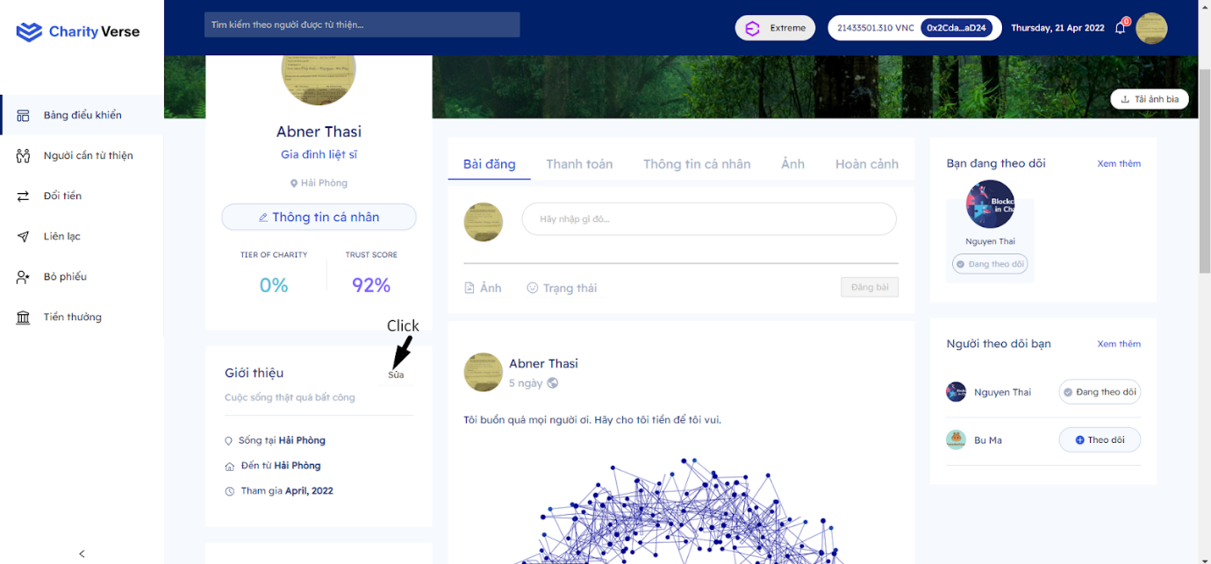

Step 1: Click button “sửa”

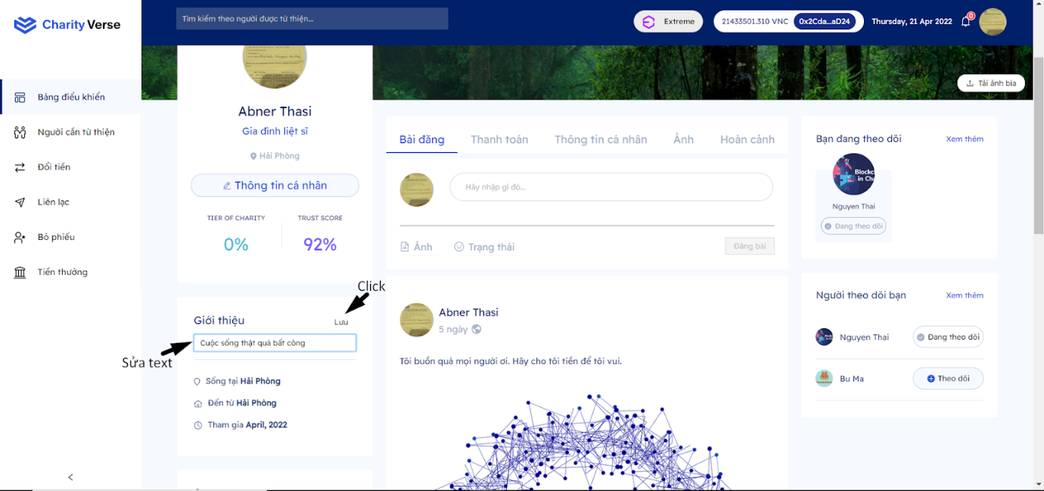

Step 2: Editing text

Step 3: Click “Lưu”

8.2.1.3 Follow another

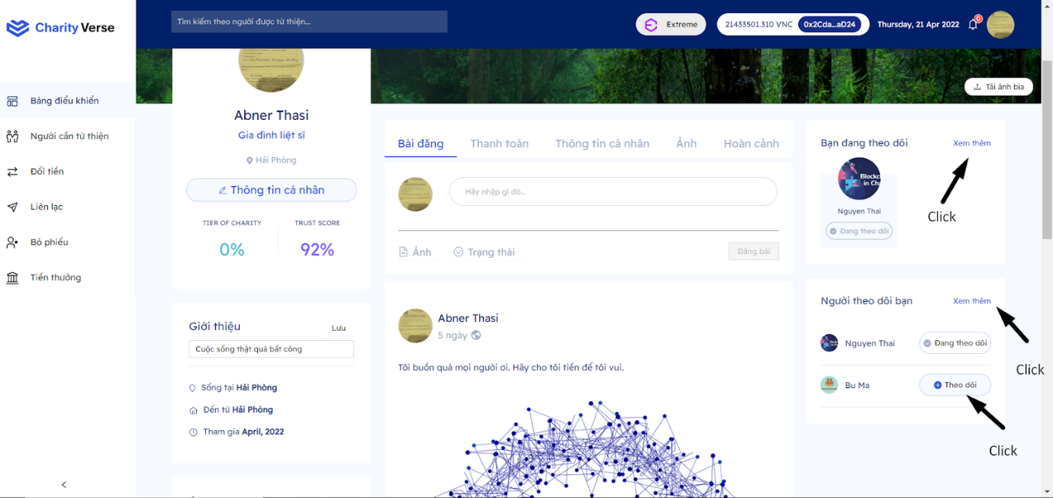

Step 1: Click “Theo dõi”

Step 2: You can see a detailed list by clicking on the links to see more

8.2.1.4 Update ảnh bìa

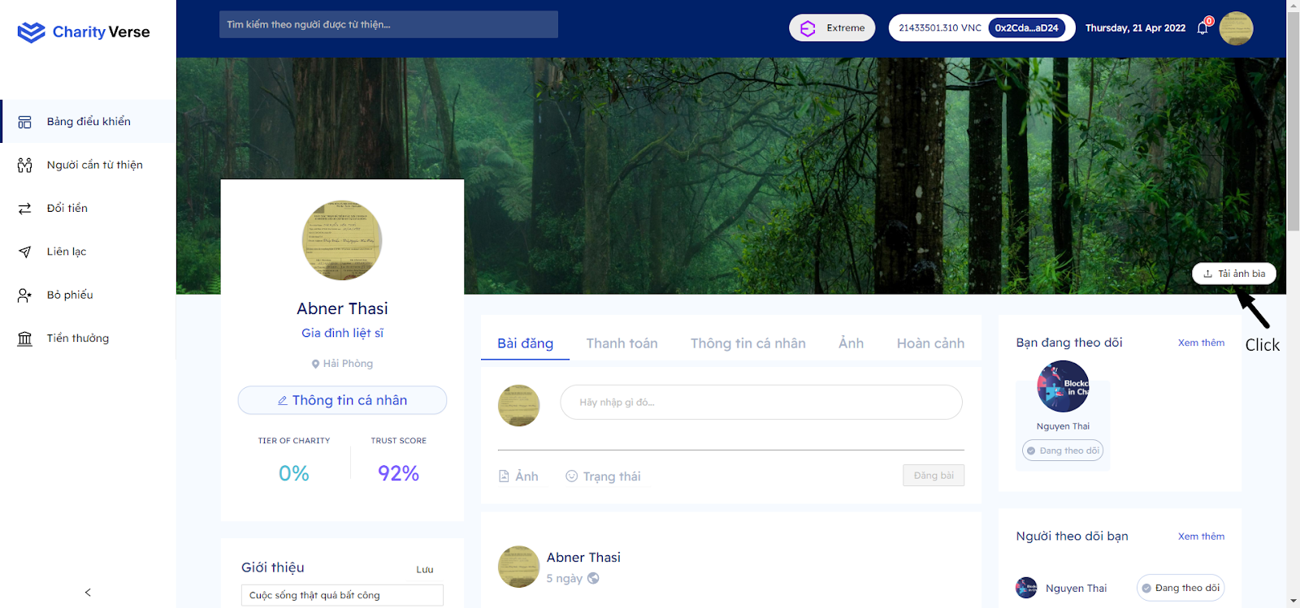

Step 1: Click “tải ảnh lên”

Step 2: Uploading photo

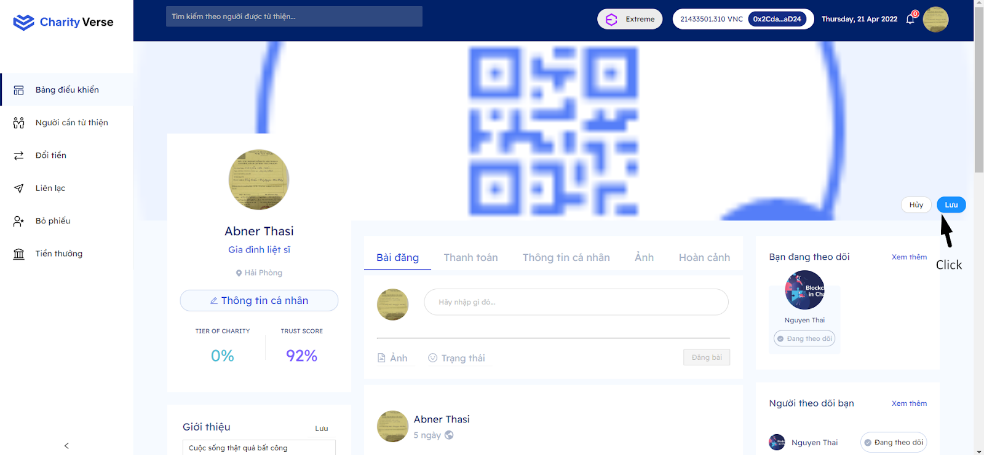

Step 3: Click lưu

8.2.1.2 Payment methods

Same function as item 8.1.2

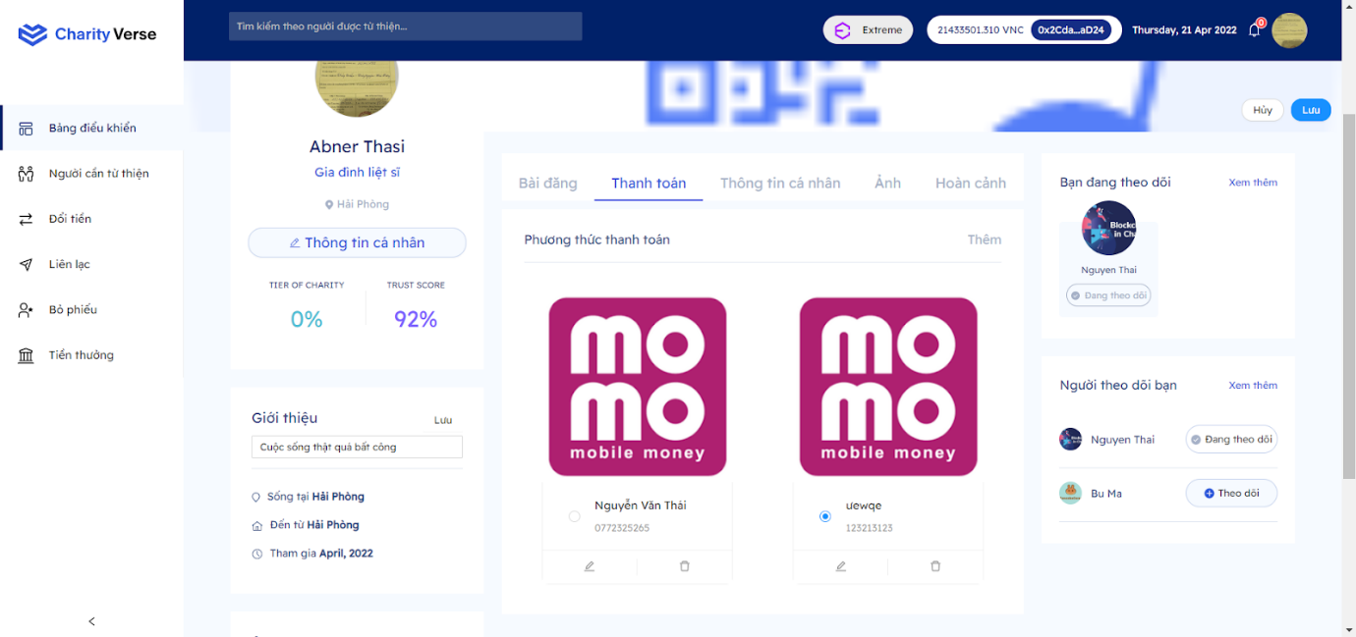

Step 1: Click tab “Thanh toán”

8.2.1.3 Thông tin cá nhân

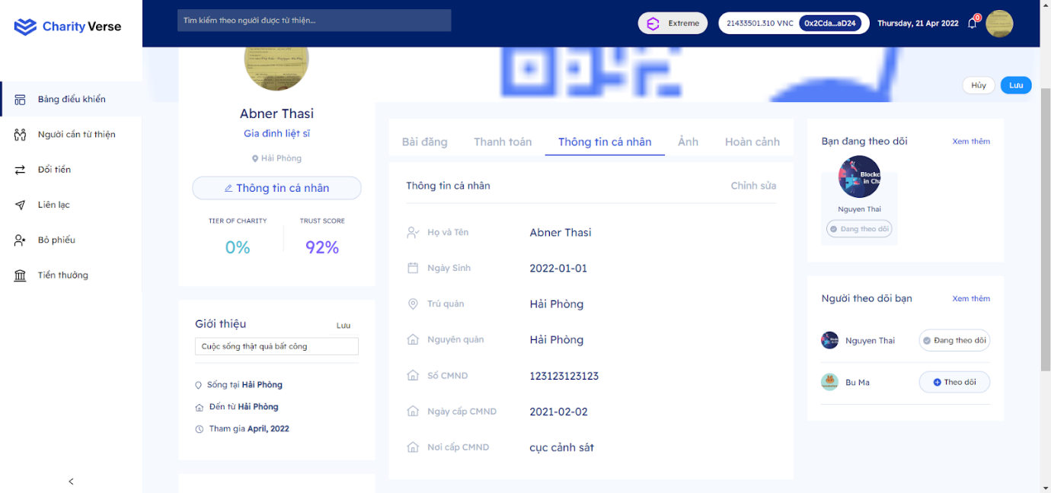

Step 1: Click tab “Thông tin cá nhân”

Step 2: If you want to edit, click the edit button

8.2.1.4 Image

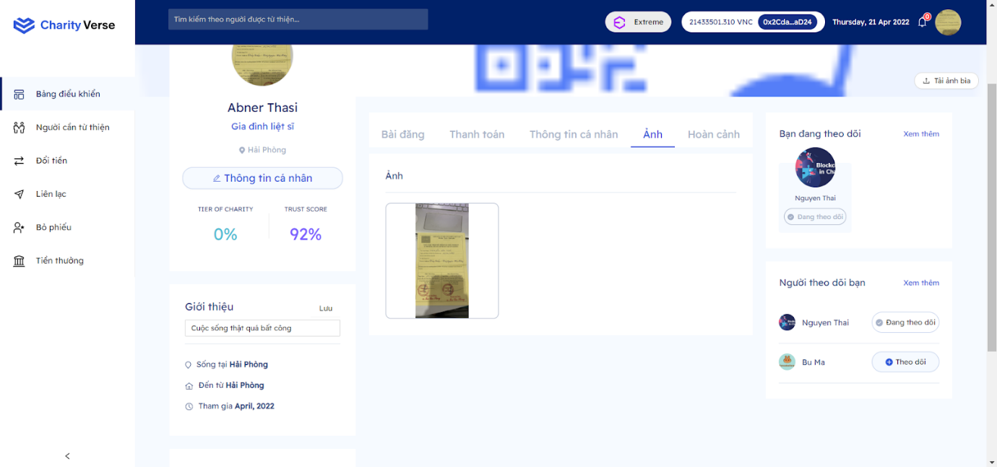

Step 1: Click tab “Ảnh”

8.2.1.4.1  Set image avatar

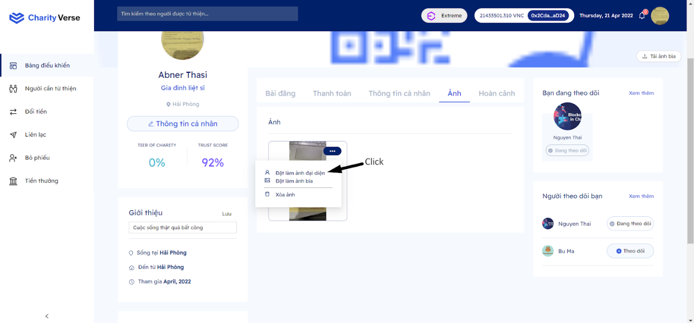

Step 1 : Click button ”...”

Step 2: Click “Đặt làm ảnh đại diện”

 8.2.1.4.2  Set image cover

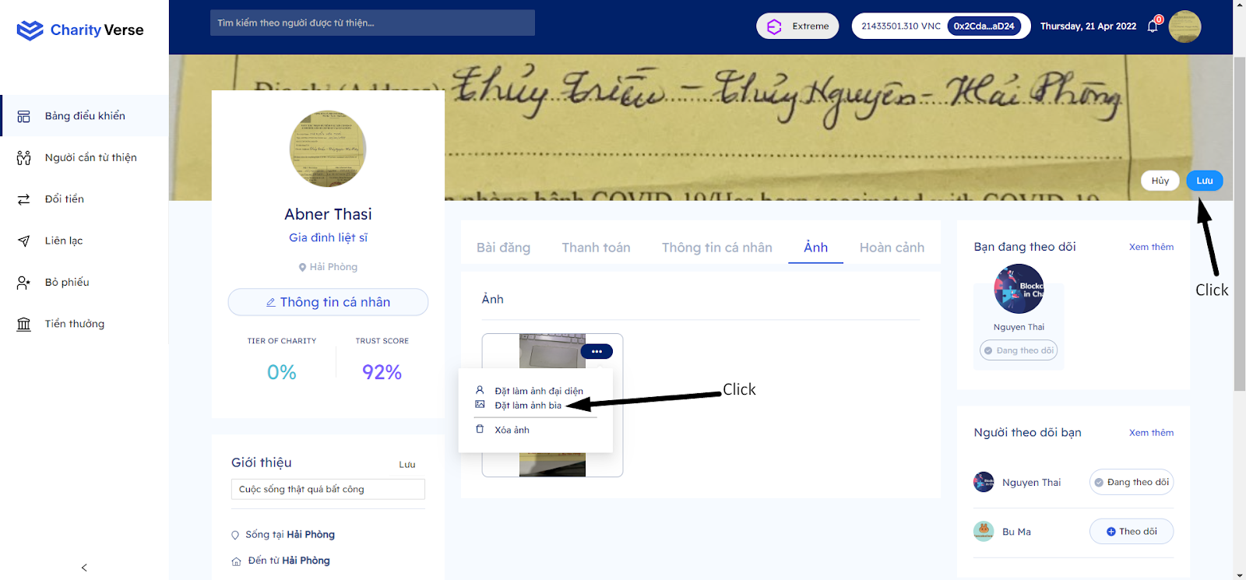

Step 1 : Click button ”...”

Step 2: Click “Đặt làm ảnh bìa”

Step 3: Click “Lưu”

8.2.1.5 Situation

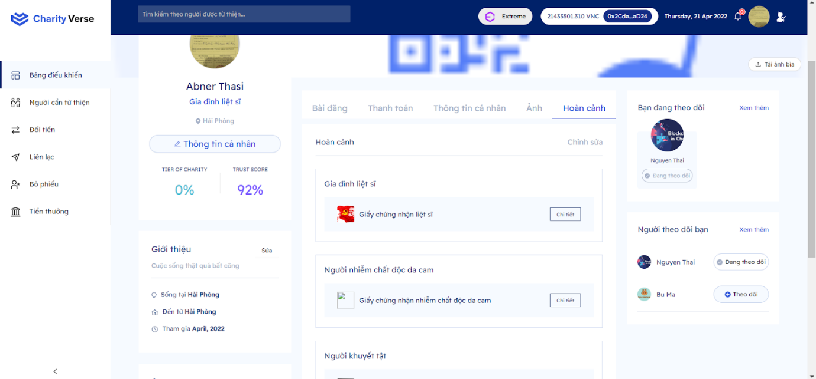

Step 1: Click tab “Hoàn cảnh”

Step 2: Click “Chỉnh sửa” to go to the edit situation page

Step 3: Click “chi tiết” to see the certificate photo

8.2.2 Another Page

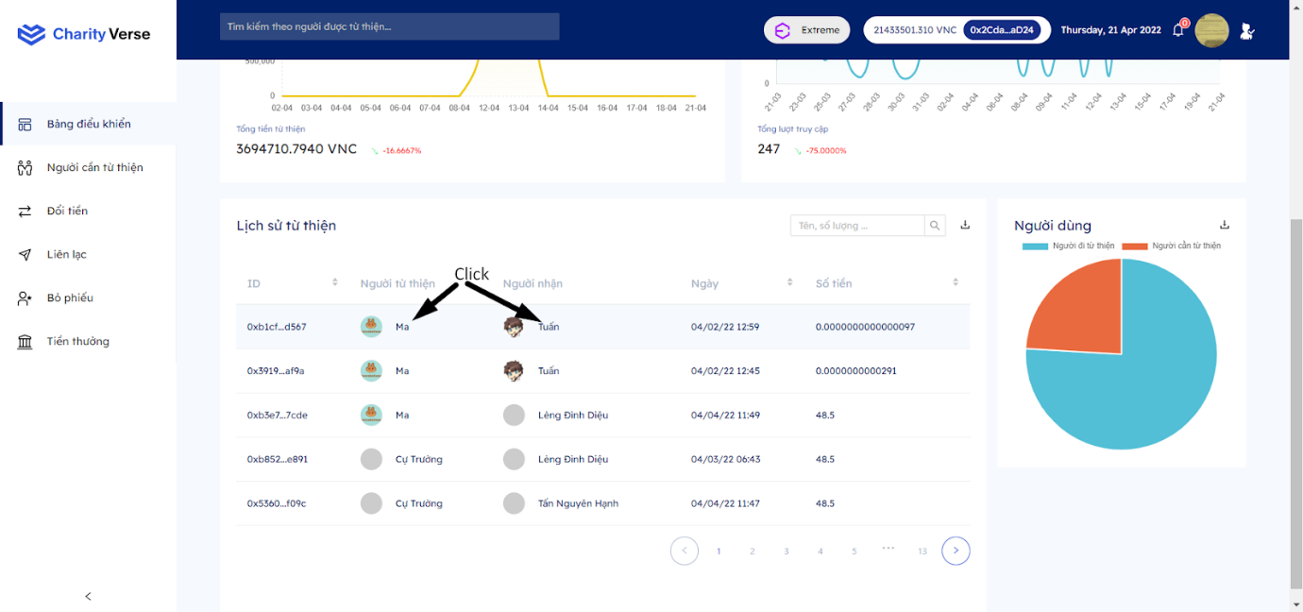

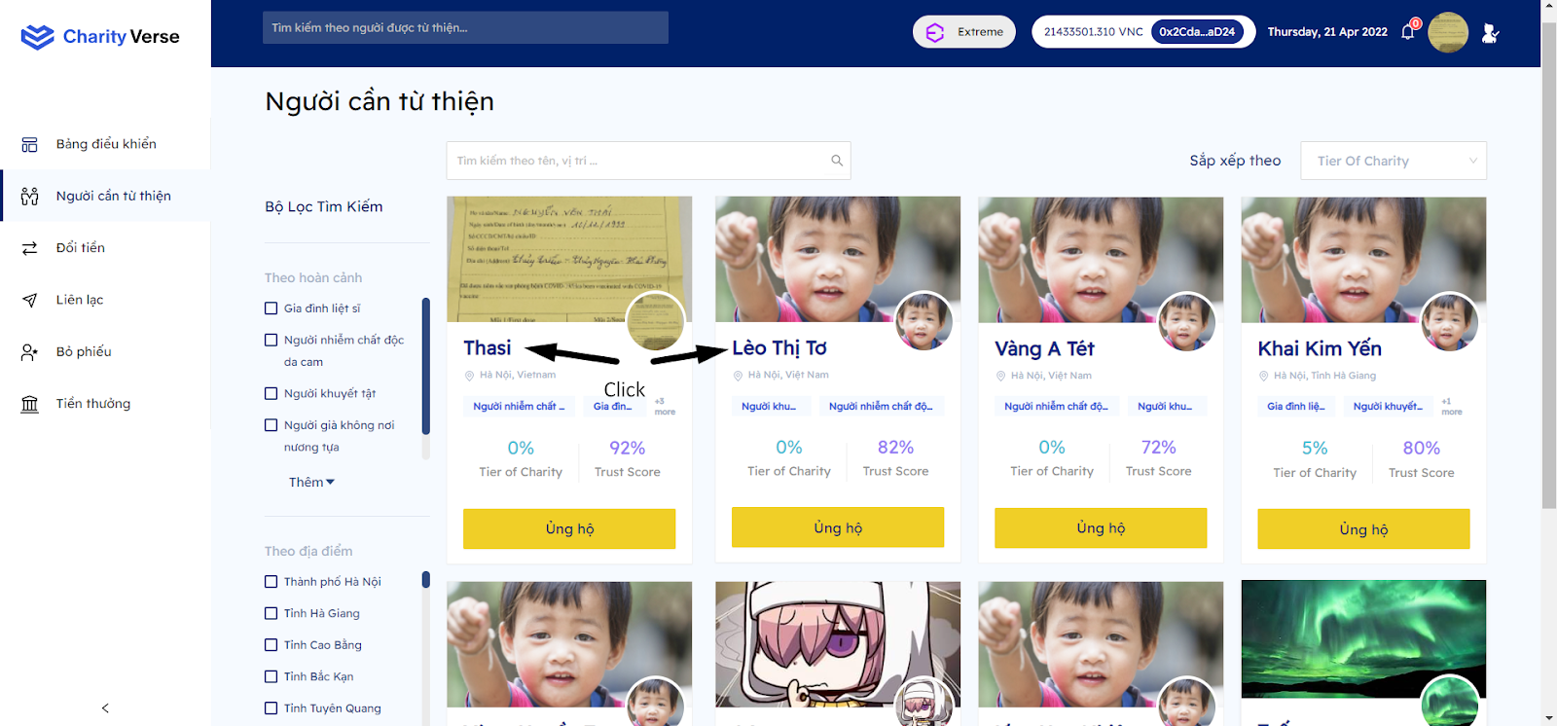

Step 1: Click someone else's name to go to that person's page

8.2.2.1 Follow

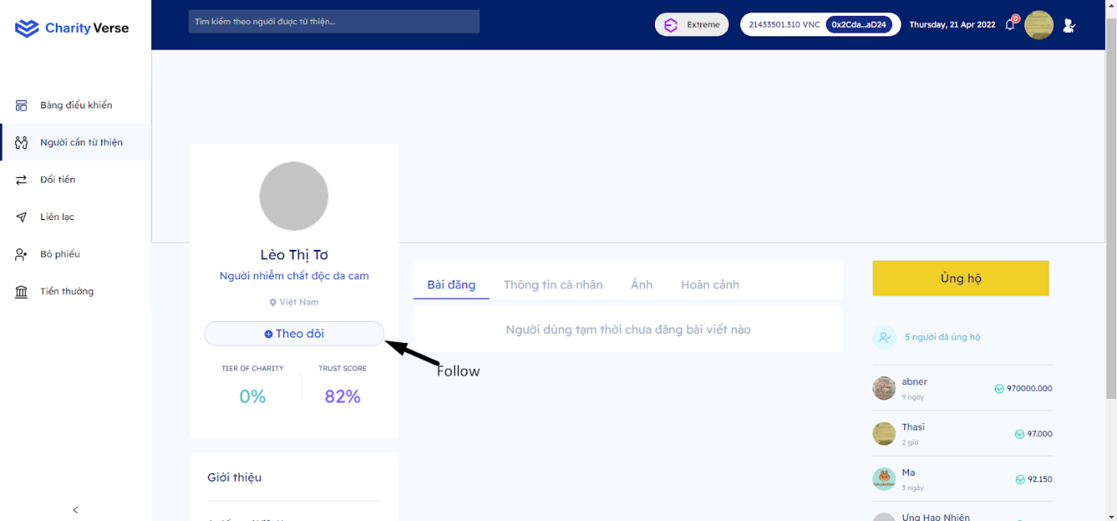

Step 1: Click “follow” to get a notification every time that person posts

8.2.2.2 Ủng hộ

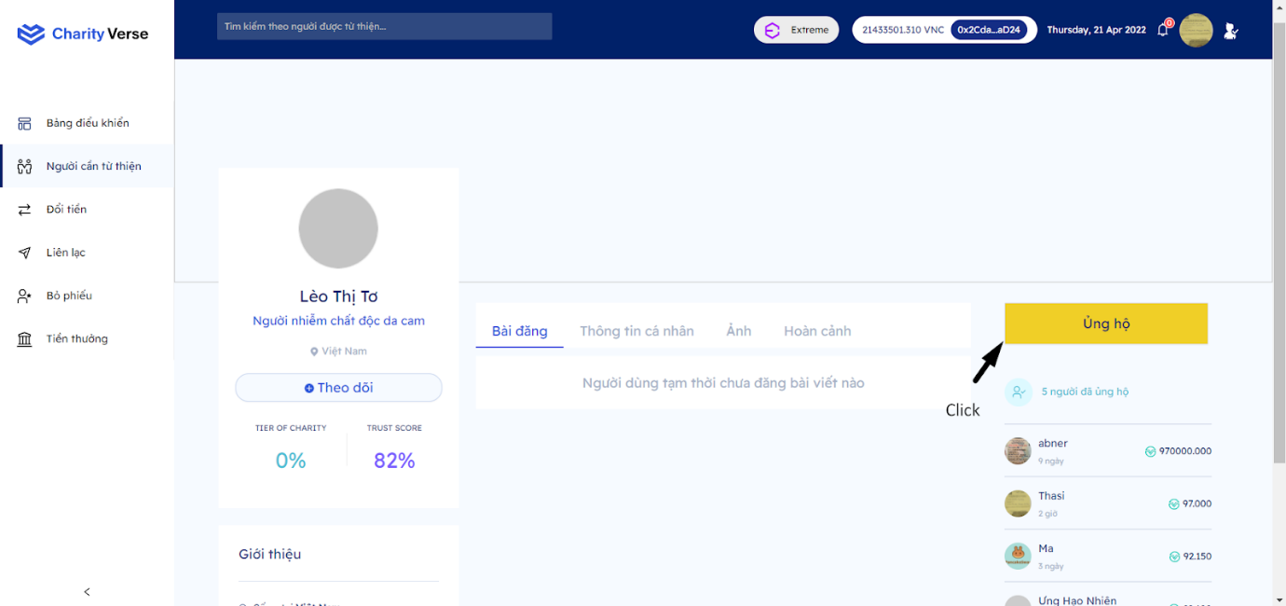

Step 1: Click “ủng hộ” to support that person

Step 2: Do the same as the steps in section “4.6 Donate”

8.2.2.3 View list of people who supported

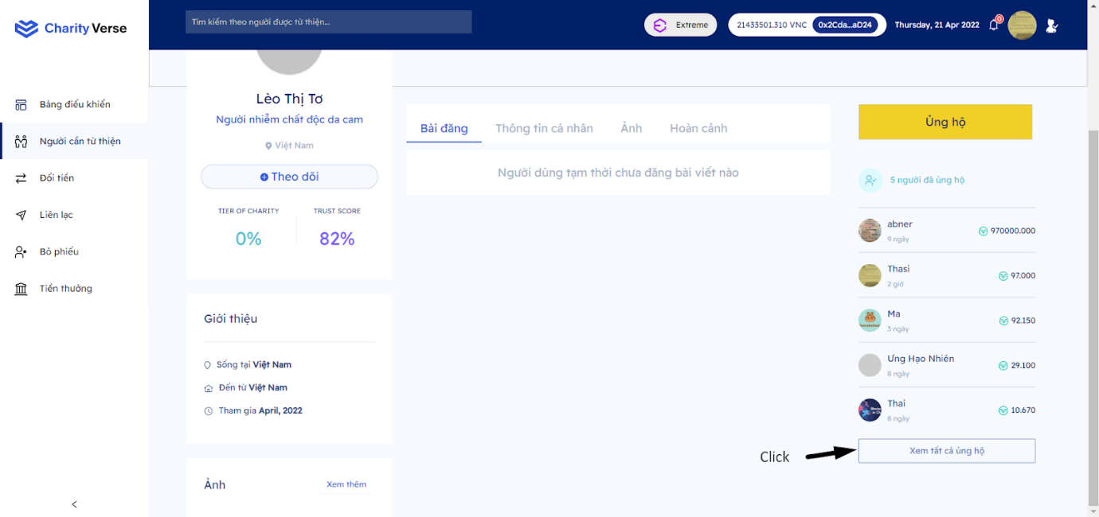

Step 1: Click “Xem tất cả ủng hộ”

8.2.2.4 View information

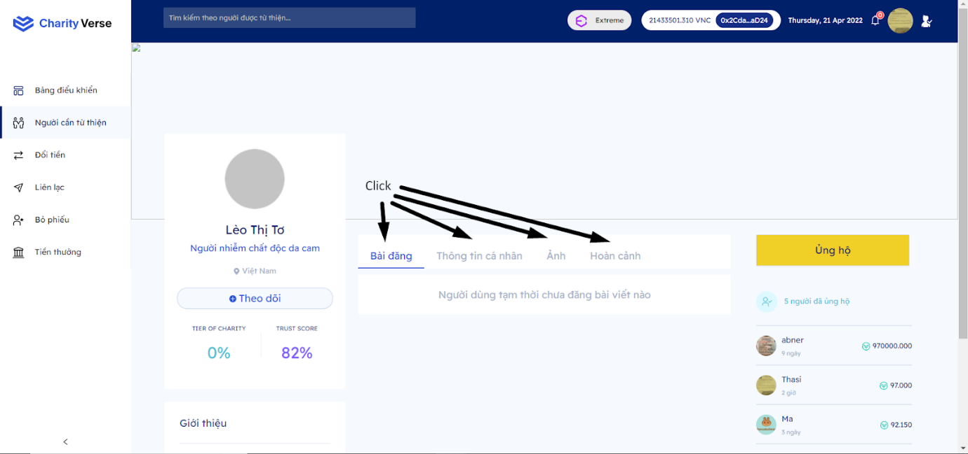

Step 1: Click the tabs to see their information

8.2.2.5 Vote situation

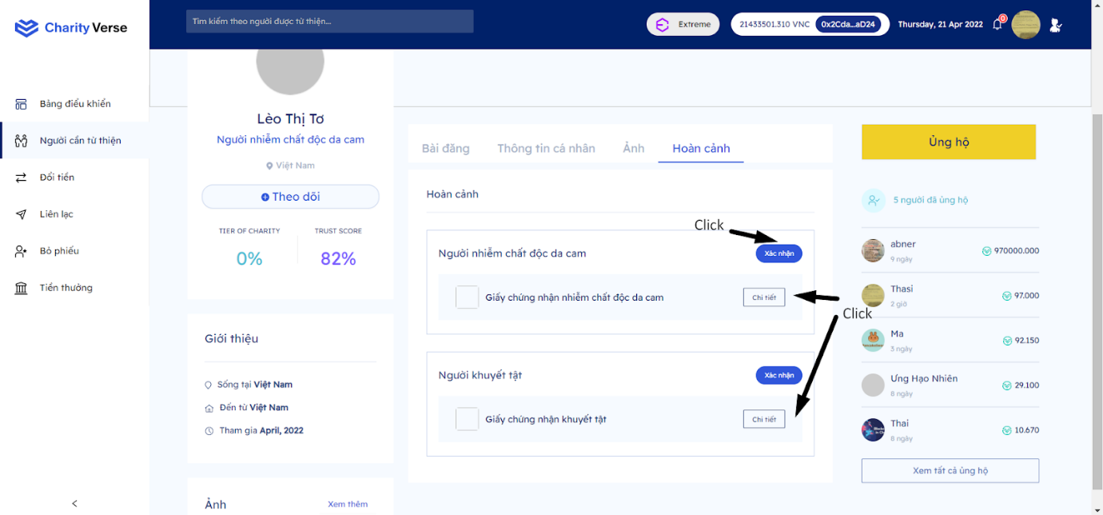

Step 1: Click tab “hoàn cảnh”

Step 2: Click “chi tiết” to see details of documents

Step 3: Click “xác nhận”

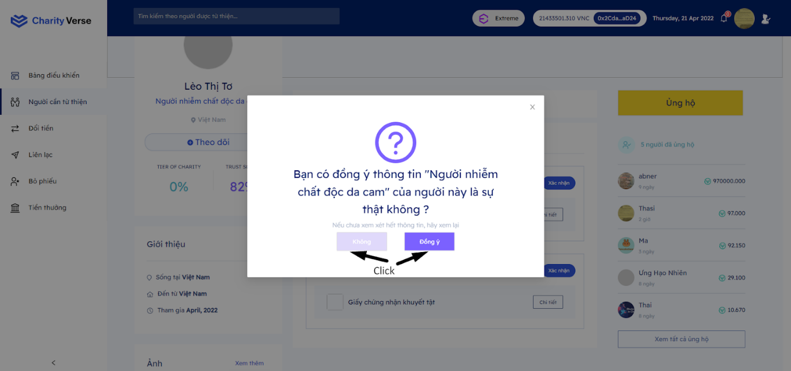

Step 4: Click “đồng ý” if you agree the situation is true, not otherwise